



CARE TEAM

GUIDE
Table of Contents
Characteristics of the team 5
Team Name 5
Mission of Team 5
Scope of Team 5
Meeting Frequency 5
Size of Team 6
Diversity of Membership 6
Team Leadership 6
Core Membership of Team by Position 7
Chairperson 7
Student Conduct 7
Case Manager 8
Director of Counseling Services 8
Residential Life Specialist 8
Campus Safety 8
Faculty Liaison 9
Director of Health Services 9
Ad-hoc/Secondary Membership 9
Common Terminology 9
Team Budget 10
Marketing of Team 11
Training of Team 11
Range of Interventions 11
Case management and support 13
Team Processes 13
Determining Risk Level 13
General Risk 14
Mental Illness Risk 14
Violence Risk Assessment (VRA) 14
Meeting Process 15
Development of the Agenda 16
Assignment of Case Lead 17
Case Presentation & Intervention Plan 17
No New Cases 17
No Canceled Meetings 18
Case Review 18
Reporting 18
The Reporting Process 19
Who Shares with CARE? 19
What is Shared? 19
Examples of In-Person Disruption 20
Examples of Online Disruption 20
Examples of In-Person Dangerous Behaviors 20
Examples of Online Dangerous Behaviors 21
Equitable Processes 21
Bias Mitigation 22
Cultural Competency 23
Processing of a Case 24
Receipt of a Concern 24
Triage of the Concern 24
Creating a Case 25
Closing a Case 25
Three Phases of CARE Process 25
Data Gathering 26
Analysis of Risk 29
Development of a Risk Mitigation Plan 29
Process for Determining Suicide Risk 30
Overview of Suicide Risk Assessment 30
Researched-Based Approach to Addressing Suicide Risk 30
Risk Factors for Suicide 32
Protective Factors for Suicide 32
Levels of Risk 33
Low Risk 33
Moderate Risk 33
High Risk 34
Process for Determining Harm to Others Risk 36
Overview of Harm to Others Risk Assessment 36
Risk Factors for Harm to Others 37
Protective Factors for Harm to Others 38
Levels of Risk 38
Low Risk 38
Moderate Risk 39
High Risk 40
Process for Determining Interventions 41
Assignment of Staff 41
Plan for Follow-up 42
Timeline for Outcomes 42
Documentation 42
Best Practices 42
Privacy and Confidentiality Policy 42
Process for Referrals 43
Data Sharing Process 44
Team Standards 45
Working with Faculty 45
Working with Staff 46
Building a Community 47
Working with Student Conduct 47
Evaluation of Team 48
Appendix A: Pathways Tool 51
Appendix B: Reporting Form 55
Appendix C: Website 56
Appendix D: NABITA Risk Rubric 57
Appendix E: Cornell Risk Levels 59
Appendix F: TEAM Member Agreement 60

Characteristics of the team

Team Name
[UNIVERSITY] has chosen [TEAM NAME] as the name for their group charged with identifying early risks and collaboratively analyzing the risk and developing an intervention plan. Given the wide range of team names across colleges and universities, there is some benefit to choosing a common name that more easily allows community members to share a concern with the team. When selecting a team name, the goals should be to communicate clearly to the campus a sense of the team’s purpose and intention and to encourage communication between the community and team related to concerns. Names should be accurate, avoid stigma, and not be inflammatory. Lake et al. suggests they be called the “Canary in the Coalmine Teams,” because they often serve as a first indicator of potential difficulties. Naming the team is the first step in communicating to the campus community the team’s purpose. Although some teams have been labeled threat assessment teams or have included “threat assessment” in the title, if the purpose of the team’s name is to encourage the community to share concerns with the team, then avoiding a team name that includes “threat assessment” would be advisable because of potential negative reaction on campus and because threat assessment is a well-defined and researched process that these teams may or may not actually practice.

Mission of Team
[TEAM NAME] is a multi-disciplinary, collaborative group of seven to ten core staff and faculty who meet weekly to review concerns shared with the team, assess the level of risk, and develop an intervention plan that is timely, appropriate, and commensurate with the level of risk. The collection and analysis of data and the intervention plans are culturally competent, consider disability and difference, and are adopted in a timely manner to match the current level of risk.

Scope of Team
[TEAM NAME] is concerned with actively enrolled students and their spouses, campus visitors, perspective students, and those engaged in work-study, internship, and practicum studies. A separate process addresses faculty and staff at [UNIVERSITY] as well as other community members, such as spouses and siblings.

Meeting Frequency
[TEAM NAME] meets bi-weekly for sixty minutes. This meeting can be in person or via online video conferencing. Most college and university CARE teams meet weekly for 1 hour to provide a frequency of communication and sufficient meeting time to discuss previous cases, develop action plans, and to introduce new cases. Teams that meet less frequently lose the ability to respond quickly to emergency situations and follow up on action items to ensure the team members are completing the tasks that they are assigned. The ability to communicate effectively electronically can make meetings, and the time in between the meetings, much more efficient and communicative.

Size of Team
[TEAM NAME] sets its core membership in the range of seven to ten members. The rationale for this range is balancing the dangers of having a small team of three to four that will lack the scope and range of information it would need to accurately assess violence and risk versus a larger team that creates an atmosphere where team members are less likely to share important, private information out of fear “it will get all around campus.” Finding the ideal team membership size that keeps it small enough for privacy, but large enough to perform functionally can be a challenge. Edward Hall (1976), a psychoanalyst and anthropologist suggests eight–12 as an ideal range. He writes, “This ideal size is between eight and twelve individuals. This is natural, because man evolved as a primate while living in small groups… Eight to 12 persons can know each other well enough to maximize their talents” (p. 203).

Diversity of Membership
[TEAM NAME] is dedicated to including the perspectives of diverse, multi-disciplinary team. This means the team strives to be diverse related to race, ethnicity, religion, politics, gender, sexual orientation, gender-identity, physical disability, mental illness, socio-economic status, position (job title) and generation (age). The reason for this diversity is to create and nurture a team that can mitigate bias and view the collection of information, the analysis of risk, and the development of intervention plans from a strong position with various perspectives considered. This diversity allows the team to better assess contextual factors that may impact the level of risk.

Team Leadership
The chair for the CARE team is a single position held by the [POSITION]. “The team leader should be a senior student affairs administrator who has high-level authority to manage student behavior and who has a solid understanding of the institution’s administrative structure, the institution’s policies and procedures concerning student conduct, and the complexity of managing difficult student situations.”
While the team is expected to operate collaboratively, the leader of the team ensures the process is followed, the team is trained well, and everyone understands their roles. Each person on the team has a responsibility to support of team goals and lead on projects. However, it is up to the leader of the CARE team to keep discussions productive and focused while maintaining a long-term view of team development and education. A CARE team chair must be vested with the authority to compel students to complete psychological and threat assessments, address academic concerns, and refer students to the conduct office with the recommendation to separate them from the university. A team leader without the authority to act on these issues runs the risk of identifying a high-risk situation and not having the ability to mitigate the risk by responding with an appropriate action.
NABITA puts it this way, “A team leader must possess the ability to compel students to complete psychological and threat assessments, address academic concerns and separate a student from the university. A team leader without the authority to act on these issues runs the risk of identifying a high-risk situation, but then lacks the ability to mitigate risk by responding with an appropriate action.” Team leaders should not be confined by counseling and medical confidentiality. A leader should also possess a certain charisma and garner respect from the other team members and the greater campus community. A leader who does not have respect and the ability to persuade and motivate others lacks the skills to properly manage the group process of the team. Eells and Rockland-Miller suggest a team leader should be “well respected and have outstanding communication skills and judgment.”
The team leader should have a commitment to the team’s mission statement and vision. They build buy-in between the community and the CARE team, ensure the training schedule of the team is developed and followed and ensures the meeting process is followed during meetings. When the team leader is not available, there is a secondary leader that coordinates the leadership. For [TEAM NAME], this is [POSITION].
The following list of team members are each asked to sign the agreement provided in Appendix F.

Core Membership of Team by Position

Chairperson
This position leads the team and has the following responsibilities to grow, lead, and support the team. They also help bring forward conduct cases that have multiple department involvement or health and safety risks to the individual or the larger community.
- Outlines and develops the structure of the meetings
- Supports individual team members in their professional development, problem solving, and case analysis
- Develops relationships with existing departments and the community and represents the forward-facing vision of the team
- Ensures critical team processes are assigned and managed, including team marketing and advertising and the consistent application of the risk assessment process

Student Conduct
- Brings cases to team from the student conduct department that are appropriate for review
- Coordinates CARE team related consults on higher level cases that involve interim suspension, longer separations, and expulsions
- Coordinates no-contact, no-trespass, and restraining orders

Case Manager
This position focuses on the intervention process and ensures that as students are assessed, they have appropriate intervention plans that are managed and maintained while there is an elevated risk level.
- Offers support and connection to students who may need to access support services such as counseling, advising, and mentoring
- Coordinates and maintains active case management plans for CARE team students who are being followed with an active intervention plan
- Provides guidance and educational programing to support CARE team and case management processes
- Serves as co-chair of the CARE team in absence of the chair

Director of Counseling Services
This team member offers consultation on mental illness related concerns and cases that come to the team. Of note, this position is governed by a higher standard of confidently and may be restricted in their ability to share details of current cases with the team.
- Offers consultation, advice and guidance on issues that arise related to mental illness concerns in the [UNIVERSITY] community
- Shares information about a specific scenario to coordinate care and interventions when a release of information is signed between the CARE team and the counseling student
- Provides guidance and advice related to psychological assessments and suicide assessments

Residential Life Specialist
This team member addresses concerns related to the residential life program at [UNIVERSITY]. They coordinate minor conduct conversations and mediation with students and bring cases to the team that involve residential students.
- Discusses impact of behaviors on the residential life halls
- Coordinates and supports the CARE team and case management to ensure interventions
- Provides contextual feedback for students involved with the CARE team as they live in the halls

Campus Safety
This position represents law enforcement and security concerns that are connected infractions or violations of the law.
- Assists in gathering evidence and providing context to cases on the CARE team known by their department
- Coordinates on sanctions related to no-trespass, no-contact, and restraining orders
- Coordinates on separations, suspensions, and expulsions
- Acts as subject matter expert (SME) in threat assessment and criminology

Faculty Liaison
This position serve the team by coordinating communication between the team and the faculty.
- Provides information related to academic involvement and expectations
- Speaks with faculty at the direction of the CARE team chair to communicate concerns and assess challenges
- Provides perspective and insights to the team related to academic issues students may be experiencing

Director of Health Services
This position serves the team by coordinating communication between the hospital and medical team and the CARE team.

Ad-hoc/Secondary Membership
- HR Representative

Common Terminology
The world of threat assessment and behavioral intervention has a unique language and terminology that are important to understand when communicating between departments. If a large part of the CARE process is building connection among departments and various stakeholders, understanding the language related to threat, law enforcement, mental illness, and college and university structures is essential.
- Actionability: The likelihood that an individual has access to the means and materials to carry out an attack
- Action/Time Imperative: The time, location, and movement toward an attack location
- BIT: Behavioral intervention team
- CARE: Campus assessment, resources, and evaluation
- CCT: Clinical crisis team
- DEI: Diversity, equity and inclusion
- DOS: Dean of students
- Fixation/Focus: Threat assessment terms that refer to a narrowing down on a particular target (e.g., fixation on women, focus on women in a sorority house)
- GPC: Graduate program coordinator
- Legacy Token: Writing or social media content that has a manifesto or justification for an attack quality
- LOA: Leave of absence
- Maxient: A database software platform used by the CARE team
- PI: Principal investigator or advisor
- POC: Person of concern (typically used in law enforcement, though POC may also refer to a person of color outside of law enforcement)
- Reporting Party: Often used in sexual assault or harassment cases to refer to the person making the report; also commonly referred to as the victim
- Responding Party: Often used in sexual assault or harassment cases to refer to the person who the report is made against. also commonly referred to as the accused or the perpetrator
- SCS: Student counseling services
- SOC: Student of concern
- SOP: Standard operation procedure
- VPSA: Vice president of student affairs

Team Budget
Teams have an established budget to meet their ongoing needs and the communities they serve,, CARE teams receive funding through several processes across institutions. Teams should have an annual budget allocation, and this may be created by departments pooling existing funding. Various offices may fund important and foundational items, such as database systems and trainings, and these funds should be transferred or allocated directly into the CARE team’s budget. Budgets should include a variety of expenses, such as printing costs for brochures, marketing posters, trainings and conferences for team members, and organizational memberships
The CARE team budget at [UNIVERSITY] is [ESTIMATED]. This is divided into categories as shown in Table 1.
Table 1, CARE Team Budget
Category | Cost
Training (virtual, in-person, books, memberships) | $5000
Conference and Professional Development | $3000
Conference Attendance and Travel | $6000
Advertising and Marketing of Team | $1000
Maxient database system | $10,000
 | Estimated

Marketing of Team
Teams should acknowledge the need to market their services and educate and train their communities around the importance of sharing concerns with the CARE team. This should include how students should share concerns with the team through marketing campaigns, a CARE website, team logo, and a ‘road show’ to share with the community the work of the team.,
[TEAM NAME] has a website that is located at [WEBSITE] (see Appendix C). This offers community members the opportunity to share concerns related to academic and personal risk as well as threats to the safety of the [UNIVERSITY] community. To further encourage sharing of concerns, the team reaches out to one department a month to offer a training on what should be shared with the CARE team and answer any questions they may have.

Training of Team
[TEAM NAME] is dedicated to ensuring its team members engage in a continuous training plan on a variety of topics. The CARE teams engage in training related to BIT functions, risk assessment, team processes, relevant laws and policies, and topical knowledge related to common presenting concerns,
To achieve a successful, continuous training program, the team has developed a yearly training schedule found in [LINK].

Range of Interventions
[TEAM NAME] makes use of research-based interventions that are matched to the level of risk and monitored and managed over the course of the student’s connection to [UNIVERSITY]. A critical part of this function in ensuring interventions are assigned after the assessment of risk and are re-evaluated through an on-going process until a case is closed. By having a range of interventions associated with different levels of risk, behaviors, and actions, they intensity of monitoring and the nature of the interventions will shift. The kind of support needed for homesickness will be different from the support needed for a student who is having suicidal thoughts. The Higher Educational Mental Health Alliance (2013) describes it this way: “Once the team has received and assessed information, it can consider whether or not further action or monitoring is needed — and what form it should take.”
CARE team interventions at [UNIVERSITY] include follow-up plans, information-gathering, case management, referral to support resources, consideration of parental notification, involvement of law enforcement intervention, requiring a psychological assessment, threat/violence risk assessment, interim suspension, and expulsion. Simply put, “Once a level of risk or threat is determined using a tool, the CARE team then deploys the intervention techniques and strategies appropriate to that level of risk.”
The CARE team first gathers information when the case is brought to the team, however this process continues throughout the management of risk to determine the need for alteration and change. This allows interventions to be tailored to ensure they are both efficacious and effective. As the National Threat Assessment Center writes, “Once the team has received and assessed information, it can consider whether or not further action or monitoring is needed — and what form it should take.”
Some practical examples of interventions include:
- Referral to services like counseling, academic support, and career counseling
- Connecting student to social supports to reduce feelings of hopelessness
- Encouraging healthy eating, exercise, and social connections
- Discussing how stressors impact the student’s decisions making
- Identifying triggers that escalate behavior and discuss alternative actions
- Exploring goals for future and strategies for improvement
- Discussing the harm-reduction approach and how it applies to current behaviors
- Identifying times they were able to overcome challenges and difficulties
- Assessing the need for conduct involvement and progressive discipline
- Monitoring on-going behavior with check-in meetings and phone calls
- Exploring connection to parents and consider larger case management approach
- Carefully documenting behavior and identifying a treatment plan
- Offering an immediate screening by clinical staff for suicide or self-harm
- Exploring the possibility of using the school medical leave policy
- Mandating the student for a Support Agreement Contract for monitoring compliance to treatment
- Immediate involvement of law enforcement and student conduct
- Exploring the possibility of a temporary/permanent estrangement from the institution

Case management and support
Case management is a unique program at [UNIVERSITY]. They are a part of overall CARE team, but also a separate department. Case management can be described as resources wrapped around the student to ensure they have the best chance at success moving forward. Following the intake appointment, case management works with the student to develop an intervention plan and partners with the student to meet their academic goals.
Case management is different than clinical counseling and psychotherapy, which is more focused on determining a diagnosis, developing a clinical treatment plan, and providing that mental health treatment to the student. This involves a higher level of confidently and privacy than is afforded to those working in the case management process. The benefit to this is an easier path within case management (compared to the counseling center) to work collaboratively with the CARE team and being able to share information more freely.
Case managers use a solution-focused approach, identifying what can be done, rather than what has held the student back in the past. Case managers have a wide range of job duties. These include completing intakes and risk assessments, assisting students in being able to connect to relevant supports, developing plans for academic success, and fostering resiliency, grit, and self-reliance.
In a joint paper published by NABITA and the American College Counseling Association (ACCA) they wrote, “case management, at its very core, is about helping students to overcome the obstacles they encounter in their lives. This is central to the educational mission of most institutions of higher education, which seek to retain students and provide them with an environment conducive to academic success. Case management can serve as a keystone mechanism through which universities support and keep students safe.” Case management at [UNIVERSITY] exists within each team member’s work with students and, in a more formalized manner, as a separate department with its own intake process and approach to providing care. Whether it is part of the CARE teamwork or within the case management department, the focus is helping students overcome obstacles they encounter during their academic pursuits. Case managers help to improve communication among those involved in the student’s success and identifies solutions to overcome barriers or obstacles in the way of allowing the student to following through with their existing goals.

Team Processes

Determining Risk Level
Risk level on the team is assessed by using the Pathways tool provided by DPREP. This is included in Appendix A in this guide for reference. Risk Levels are assigned at low, moderate, and high. Each level has corresponding interventions that are suggested. The automated version is available here: [link]. Other rubrics are used on the case as appropriate. The following is a summary of the common risk levels used by the CARE team.

General Risk
Pathways: The Pathways risk rubric can be used for every case coming before your BIT, CARE, or threat team. Each applicable category is rated on a 3-point scale. After you submit your ratings, you are provided a set of intervention recommendations.

NaBITA Risk Rubric: The NaBITA Risk Rubric (Appendix D) is designed to assign a specific level of risk to each case discussed by the BIT, each time they are discussed. NaBITA offers a few resources and guidance that can help new teams move through the analysis and discussion as they apply the risk rubric (www.nabita.org). The D-Scale assess affective violence while the E-scale assesses targeted violence. The center offers a range of risks from mild to moderate to elevated to critical. The second page of the risk rubric supplies a general collection of interventions.

Mental Illness Risk
Suicide Waypoint by InterACTT: This expert system rises above traditional pen and paper assessments and intervention plans for suicide risk. It takes the guess work out of these processes, as it guides counselors, human resource professionals, and CARE and threat team members to work through a series of questions which will be used to develop an intervention plan and have clear documentation to support these interventions. Based on best-practices and in-depth research, your answers will be assembled and analyzed by the system to create a risk level and risk-based suggestions for suicide interventions.
Beck Depression Scale, Suicide Scale, Hopelessness Scale: This series of four symptom measures includes the Beck Depression Scale-2 (BDI-2) created in 1996, Beck Anxiety Inventory (BAI) created in 1990, Beck Suicide Scale (BSS) created in 1991 and the Beck Hopelessness Scale (BHS) created in 1988. These tests are available for computer scoring and offer the ability not only to assess baseline functioning in these areas but also to be given over time for comparison of symptoms. www.pearsonassessments.com

Violence Risk Assessment (VRA)
DarkFox: DarkFox is an expert system that collects and organizes data related to a potential violence risk. The information shared is used to develop a unique threat management plan supported by research from the fields of psychology, criminology, threat, and law enforcement. This expert system rises above traditional pen and paper assessments and intervention plans for assessing threats to others. It takes the guess work out of these processes, as it guides counselors, human resource professionals, and CARE and threat team members to work through a series of questions which will be used to develop an intervention plan and have clear documentation to support these interventions to better manage threat. Based on best-practices and in-depth research, your answers will be assembled and analyzed by the system to create a risk level and risk-based suggestions for threat mitigation.
Cornell Risk Levels: Cornell offers a threat assessment decision tree based on his research and has developed a subsequent threat assessment and response protocol. The steps include 1) the evaluation of the threat, 2) attempt resolve the threat as transient, 3) respond to a substantive threat, 4) conduct a safety evaluation for very serious substantive threats, 5) implement and monitor the safety plan. These are included in Appendix E.
NABITA SIVRA-35 Threat Assessment Tool: The SIVRA-35 is an informal, structured set of items useful for those staff and faculty who work in higher education to use with individuals who may pose a risk or threat to the community. The SIVRA-35 is not designed as a psychological test and it is not designed to assess suicidal students. It is a guided structured interview useful for classifying risk into low, moderate, and high categories.
WAVR-21: The WAVR-21 is a workplace VRA designed to assist human resource and threat assessment professionals to work through a structured set of dynamic and static risk factors to better estimate the likelihood of violence by an employee. Though designed with a workplace setting in mind, the WAVR-21 offers some guidance to those working in a higher education environment when it comes to identifying potential risks with students, faculty, and staff. For more information about the WAVR-21 visit www.wavr21.com.
HCR-20: The HCR-20, which is in its third version, is a structured professional judgment instrument used to assess risk and develop mitigation plans. The measure is well researched and evidence based. The authors of the measure explain that risk and threat are always incompletely understood due to the uncertainty inherent in individuals’ choices. The HCR-20 is commonly used in psychiatric settings to determine release criteria, admission screenings, and inpatient psychiatric management, as well as to monitor risk in probation and parole settings. The HCR-20 is a process rather than a singular tool producing a quantitative score or measure. The seven-stage process includes: 1) gathering information, 2) identifying the presence of risk factors, 3) determining the relevance of the risk factors, 4) formulation of the motivators for violence, 5) the development of risk scenarios, 6) management, and 7) final opinions. For more information about the HCR-20, visit http://hcr-20.com.

Meeting Process
The process of each meeting should be consistent and free from external pressures of the campus workspace. This is important to ensure the meeting occurs with bias and pressures mitigated and each case is assessed, reviewed, and has interventions developed based on the assessment and review. To achieve this goal, the chair will set the agenda for the meeting. Before the meeting, the CARE team will review the agenda with the active and monitoring cases to discuss, which are updated in a timely manner in Maxient. Each member of the team provides any additional information they may have about the case. The agenda always starts with a review of previous cases and updating the action items following by the introduction of new cases. Finally, broad issues of impact to the campus are reviewed. These may include current events, political issues, and updates related to the [UNIVERSITY] community in general.
Timeliness and meeting attendance are critical issues that are addressed by the chair in a personal and timely manner. While emergencies certainly occur, there needs to be a clear statement and commitment from all the core members to be in attendance and arrive on time. Similarly, leaving the meeting early or stepping away from the case process is equally problematic and will be addressed quickly and directly. If the team member who misses meetings, shows up late, steps away during the meeting, or leaves early is not able to shift their behavior, it is better that they are not on the team and a new team member is selected.

Development of the Agenda
The agenda is made up of four main components. These are 1) a review of current cases, 2) introduction of new cases, 3) review of issues that impact the [UNIVERSITY] community, and 4) training concepts. The team chair (or their designee) will assess the number of cases against the time allotted and keep the team focused and on task.
- Review of Current Cases. The team chair (or their designee) brings a list of current, active cases to the team for review. The team member who has lead on each case should offer a brief summary of case details, an update on the current status, and the risk level assigned. The lead makes an initial suggestion of an updated risk level and action plan. Other team members are encouraged to discuss and contribute to the case until a consensus is met and there is agreement on the general level of risk and corresponding interventions.
- Introduction of New Cases. New cases should be sent to the chair of the team prior to the meeting. Ideally these should be sent at least 24hrs prior to the meeting to allow for some basic information gathering to optimize time at the CARE meeting. The chair will move through the cases by asking the team member who brought the case to offer a summary of the case details, an update on the current status, the estimated risk level assigned, and a suggested action plan. Other team members are encouraged to discuss and contribute to the case until a consensus is met and there is agreement on the general level of risk and corresponding interventions.
- [UNIVERSITY] Community Update. This is organized by the chair of the team. The purpose here is to ensure all team members have situational awareness on issues critical to the team. Some examples of topics to be discussed include political information from the surrounding communities, recent critical incidents (robbery, fire, protests/gathering, or campus safety concerns)
- Training Concepts. At each meeting, a brief training topic is offered by an assigned team member. These can be topics related to mental illness, conduct, resiliency, DEI, threat assessment, case management, student retention, etc. These can draw from the InterACTT Training Tips, which offer short overviews on a variety of topics. These concepts are scheduled for each meeting but may be adjusted for time restrictions if case review and discussions go longer than intended.
InterACTT Training Tips are concise, thematic training topics and discussions related to a variety of CARE team issues. Each includes a summary on a topic, a set of key points, additional resources, and questions to consider. These are designed to be completed in 10 minutes.

Assignment of Case Lead
One of the most critical parts of CARE teamwork is ensuring accountability in terms of case follow-up. The case lead is generally assigned to the person who brings the case to the team. The assignment of case lead is assigned by the chair or their designee.

Case Presentation & Intervention Plan
The case presentation requires the case lead to be knowledgeable about the case. Attempting to present a case without preparing will lead to an increase in distraction and down-time while that information is obtained during the meeting itself. Some key areas to consider are:
- Identifying information. Name, birthdate, [UNIVERSITY] ID number, program of study, and GPA.
- Support people. This includes family member names and identifying information, academic advisor and others who support the student in the community.
- Brief Summary. This is a summary of the presentation problem. This should be 2-3 sentences that concisely summarize the problem at hand. The opportunity for clarifying questions and obtaining other information will be given to the team members as they discuss the case.
- Risk Rating. An estimation of the risk rating based on the Pathways tool should be given. This would be at the low, moderate, or high-risk levels. The estimation is given to allow the team a place to discuss if they would concur with the risk level.
- Intervention Plan. The intervention plan is based on the risk rating and is designed to decrease risk factors and increase supportive and mitigating factors. Examples of interventions are included as part of the Pathways.
Each case presentation should ideally take 2-3 minutes. Concise presentations and brevity are prioritized to allow time for questions and discussion.

No New Cases
When there are no new cases to share, the team uses the time during the meeting to engage in a larger discussion related to training or to work through a case study. The team chair (or their designee) should have a set of case studies and other professional development exercises for the team in the event of available time for non-case purposes.

No Canceled Meetings
The cancelation of meetings has a negative effect on a few levels and should be avoided. A canceled meeting conveys to the team that there is an option to not have a meeting and creates a slight tension to end early or cancel when there is nothing pressing. It is of critical importance for the chair of the team to instill in team members the importance of each meeting and to treat this time as essential.

Case Review
As with each case presentation, being concise and focused is a priority of the case review. Questions should be focused initially on information needed to make an accurate assessment of risk. Once the risk level has been assessed, the review then moves to questions based on what intervention steps should be taken. The team chair is responsible for ensuring the flow of each case always goes from assessment to intervention. This can be challenging at times, as most people want to move to the action phase of solving the problem. By focusing on the assessment, the team can better mitigate the danger of developing a plan that 1) isn’t grounded in an assessment, 2) over-delivers on intervention steps, or 3) under delivers on intervention steps.

Reporting
While reporting is a common term, when discussed with the community it is better to describe the reporting process as “sharing a concern with the team.” While this may seem to be an issue of semantics, the way the CARE team talks about referrals is important as it relates to the marketing and the advertising of the team. Without good data, the team is limited in terms of its ability to analyze and act.
Building a successful referral network for the BIT/CARE team is essential. A team will only be effective if it receives frequent information from the community. Developing a clear information conduit from students, faculty, and staff is essential. These individuals have “eyes on the ground” and help ensure the team has actionable information to assess and analyze.
The best way to prevent violence from occurring is to encourage a culture of reporting concerning behavior on campus. Vossekuil writes, “The U.S. Secret Service found… in 81% of their cases (n=37) at least one person knew the shooter was thinking about or planning the incident, and in 59% of the cases, more than one person knew about the planning. ‘In 93% of the cases, the attackers engaged in some pre-offense “disturbing” behavior that created concern in those around him.’
It is imperative that a team reaches out to the community and encourages reporting of concerning behaviors. This community includes faculty and staff as well as student leaders who are willing to share their concerns. Kanan writes, “The need to break the code of silence that surrounds potentially dangerous behavior must be reinforced with students: telling keeps people safe.”

The Reporting Process
[TEAM NAME] supports a process of sharing a concern through multiple points of entry. On initial review, it may seem better to have an easily controlled single point of entry. While this works well to categorize the reports coming in, it does not work as well for obtaining concerns from those who are hesitant to report because of a reluctance to use technology, fear of the CARE team causing the student to be separated from [UNIVERSITY], or concerns over being targeted by the student because of the report. To this end, the CARE team takes reports in multiple ways to ensure that, above all else, the information gets in front of the team.
Concerns can be shared through a central web portal linked here: [LINK TO REPORTING FORM]. The form itself is provided in Appendix B. Allowing anonymous reporting is considered a best practice by BIT/CARE teams and [UNIVERSITY] allows this option through the online form. Concerns may also be shared directly with team members. The website for the CARE team is linked here: [LINK TO CARE WEBSITE] and team member emails are included. [UNIVERSITY] community members may also share a concern by phone.

Who Shares with CARE?
All member of the [UNIVERSITY] community have the ability and duty to share concerns with the team. Being part of a community, particularly a unique community such as [UNIVERSITY], requires each community member to take the safety and security of the community as a personal responsibility. The CARE team is in a unique position to advocate for student while balancing the safety and security of others in the community. Good information sharing with the team allows for a more accurate analysis and interventions steps.

What is Shared?
The easy answer to this question is anything that concerns a community member. It is the CARE team that will take a concern and decide the risk and intervention plan. Even if the behavior is vague or does not warrant CARE team intervention, sharing a concern with the team is still encouraged. In fact, it is even more important to encourage someone to keep sharing information when they just shared and it was below the threshold. Having a community member feel they shouldn’t have shared something with the team has a negative impact on their future reporting.
In terms of more specific information to be shared, it is helpful to provide some examples. Behaviors are separated into disruptive and dangerous categories and further described by online and in-person.

Examples of In-Person Disruption
- Misuse of technology in the classroom, such as watching loud videos on a laptop or a cell phone ringing repeatedly
- Poor personal hygiene that makes it difficult to continue a conversation
- Use of alcohol or other substances
- Frequent interruption of instructor while talking and asking non-relevant, off-topic questions after told directly to stop
- Repeated crosstalk or carrying on side conversations while the faculty is speaking
- Raising voice at classmates or faculty
- Emotional outbursts or other extreme communications in the waiting room of a campus office that significantly affects others
- Lack of focus or paying attention to conversation; excessive sighs or eye rolls
- Entitled or disrespectful talk to staff or other students
- Arguing points of contention or asking for special treatment after the staff or faculty requests the student to stop
- Reading magazines, newspapers, or books, or studying for other classes/doing other homework during a conversation with you

Examples of Online Disruption
- Posting non-relevant spam or unrelated personal advertising material in email or on website or social media page for the department
- Frequent interruption of the staff questions with non-relevant comments or off-topic personal details on phone
- Inappropriate or overly revealing pictures shared with members of the online community through the profile or staff email/website
- Choosing a screenname or profile name that is offensive to others such as Smokingthedope420@university.edu or assman69@university.edu
- Emailing or making comments while drunk or intoxicated; conducting phone calls while under the influence of alcohol or other drugs
- Arrogant, entitled, rude or disrespectful emails or messages to staff or other students
- Arguing points of contention or asking for special treatment after the staff requests the student to stop
- Inciting other students to argue with the staff over policy or other related expectations

Examples of In-Person Dangerous Behaviors
- Bullying behavior focused on students in the waiting room, outside the office or in the residence halls
- Direct communicated threat to staff or another student such as, “I am going to kick your ass” or “If you say that again, I will end you”
- Prolonged non-verbal, passive-aggressive behavior such as sitting with arms crossed, glaring, or staring at staff, and refusal to speak or respond to questions or directives
- Self-injurious behavior, such as cutting or burning self, during a meeting or exposing previously unexposed self-injuries
- Physical assault such as pushing, shoving, or punching
- Throwing objects or slamming doors
- Storming out of the office or room when upset
- Conversations that are designed to upset other students or staff, such as descriptions of weapons, killing, or death
- Psychotic, delusional, or rambling speech
- Arrogant or rude talk to staff or other students
- Objectifying language that depersonalizes the staff or other students

Examples of Online Dangerous Behaviors
- Racist or otherwise exaggerated thoughts emailed or discussed on the phone, such as, “Women should be silent in public,” “Men should go back to playing football and stop thinking so hard. Leave the mental heavy lifting to the ladies in the class,” “Christians or Hindus should be wiped off the planet”
- Bullying and teasing behavior through messages, emails, or online hazing
- Direct communicated threat to staff or another student, such as, “I am going to beat you if you don’t agree with me” or “If you say that again, I will end you”
- Prolonged passive-aggressive behavior such as constant disagreement with everyone and everything related to departmental policy, challenging the staff’s credentials, refusal to respond questions or directives
- Mentioning of self-injurious behavior, such as cutting or burning self or suicidal thoughts or intentions in emails or on social media
- Threats of physical assault such as pushing, shoving, or punching
- Threats of online assaults like hacking a website, sharing personal information, or posting pictures online without permission
- Conversations that are designed to upset other students, such as descriptions of weapons, killing or death
- Psychotic, delusional, or rambling speech in an email
- Arrogant, entitled, rude or disrespectful messages to staff or other students
- Objectifying language that depersonalizes the staff or other students

Equitable Processes
Ensuring a team has an equitable process while gathering information about a case, applying a risk rubric, and developing informed interventions ensures those [UNIVERSITY] community members who come to the attention of the CARE team are treated in a consistent and fair way. The team engages in training to ensure they are aware of their potential bias, both known and unknown, and take steps to mitigate that bias during the CARE process.
Teams don’t set out to have an inequitable process, but sometimes find themselves in this place due to a lack of prioritization and focus on tending to those factors that slowly chip away at equity. Creating a team that mitigates bias in its gathering of information, decision making, and intervention requires an active choice to guard against threats to equity, as one tends to a garden prone to weeds or hungry rabbits. In a very real way, this fosters a skeptical, inquisitive mindset when approaching a case and addresses the CARE process through a collaborate, multi-disciplinary approach.

Bias Mitigation
Bias is our tendency to see the world from our lens of experience. It can lead us to ignore evidence or make assumptions not based on evidence. It can impact what we remember and what witnesses remember. It can create blinders for BIT team members and impact their ability to build rapport, connect with students, and create safe/neutral spaces. While we can never remove bias, we can train to make us more aware of how bias can affect decision making.
When we consider our bias, we should be aware of how our experience and position in the world impact our understanding of those around us. Specifically, some examples of how we see the world include:
- Our gender, gender identity experiences, and sexual orientation
- Our race/ethnicity, world view, and generational expectations
- Experiences with mental illness or physical disabilities
- Exposures to different cultures or geographic areas
- Our religious beliefs and political experiences
- Our economic differences and experiences of wealth and poverty
- The friends, family, and peers around us

A successful team understands and mitigates the role of bias in its work gathering information, making decisions, and selecting an intervention and/or management process following the initial threat or concern. This allows the team to avoid underestimating or overestimating the risk or threat. In relationship to violence risk and threat assessment, we assess threat and/or concerning content with an awareness of research, an understanding of transient versus substantive threats, and an analysis that mitigates explicit and implicit bias and balances the interplay between evidenced-based risk and protective factors. These assessments work best when they are used as a part of a multidisciplinary team with an emphasis on evidenced best practices. Team members should be knowledgeable about their population, the BIT/CARE model, concepts related to threat and violence risk assessment, bias awareness, and mitigation, and engage in ongoing training.
Some examples of common types of bias are included here to help better understand how our information gathering, decision making, and selection of interventions may be impacted by the way we think about the world around us.
- Confirmation Bias. Here the team member may form an early assumption and progress with the case seeking to overvalue evidence that fits with and/or confirms their assumption. When gathering information, team members are encouraged to consider the question: are you interviewing or validating?
- Dunning-Kruger Effect. This is the tendency for team members to over-estimate their abilities in certain areas such as threat assessment, counseling, or law enforcement. They make assumptions that since they have had some training, they are able to reach further than they really should. This can also happen in reverse, where people who are good at a task are hesitant to share because they under-estimate their competence in the task.
- Anchor Bias. This bias can impact a team member when they become anchored or locked on a particular piece of data or first impression on a case and are unwilling to consider rival, alternative hypothesizes. The bias occurs when we rely too heavily on the first piece of information we are given about a topic. We can manage this by having group discussions and display a willingness to look behind our first impressions on a case.
- In Group/Out Group. Here a team member guards against gathering data and making decisions that are favorable toward the group that is like the team member. This could be a shared activity, place of birth, love of a sports team or connection to a group, club, or organization. We guard against this by leaning into the team experience and being aware of our personal connections, either for the good or bad, on a given case that is presented to the team.
- Blind Spot Bias. This involves a team member’s tendency to miss crucial elements of a case because they are unable to see the data from a balanced and reasonable perspective. These team members may be very good at spotting systematic errors in others’ decisions but are unable to see their own mistakes. One way this is addressed is through having a diverse team with varied perspectives.
- Availability Bias. This occurs when we lean into an over-reliance upon readily available (most recent) information. When gather information about a case, team members should guard against focusing solely on the low-hanging fruit and data around us, but rather finding the information needed to best assess the case and develop culturally competent interventions.

Cultural Competency
Cultural competence is the ability to understand, appreciate, and interact with people from different cultures and with beliefs than your own. One way CARE teams ensure cultural competency is through the membership of the team. Teams should be diverse in gender identity, sexual orientation, race and ethnicity, socio-economic status, political affiliation, religious beliefs, physical and mental disability, and age.

Processing a Case

Receipt of a Concern
Concerns come to the team in several ways. This is by design. While it may seem more efficient to limit [UNIVERSITY] community members to a single point of entry, by offering multiple points of entry, the CARE team works to ensure to avoidance of a “miss.” Avoiding a missed case is much more important than the time potentially spent processing a case that should have been sent to another primary location for processing. Community members will be comfortable with different ways of sharing a concern with the CARE team. By offering a diversity of choices, the team prioritizes receiving a concern in a format that requires slightly more processing time over processing a concern or requiring compliance with a more restrictive process. Stated plainly, [TEAM NAME] would rather have a concern shared that is not necessarily an appropriate referral and needs to be referred elsewhere, than to miss a referral the CARE team could have used to prevent violence.
Common ways concerns are shared with the team include:
- A report filled out through the online process through the CARE website
- A phone call or email with a CARE team member
- A conversation with a CARE team member
- Sharing of a third-party report such as an incident report, police report, or academic status report

While filling out the online concern form is the easiest way to for the team to receive information, we should take information in any of the above formats. As all concerns should be entered into the online form, but a team member can assist the person sharing the concern to fill out the form or can fill it out for them. As mentioned earlier, concerns can be shared through a central web portal linked here: [LINK TO REPORTING FORM]. The form itself is provided in Appendix B.

Triaging the Concern
Once the concern is received, the case manager (or the chairperson’s designee) will review the initial case details an obtain clarification or additional information needed to complete a triage assessment. Triage, a term borrowed from the medical field, implies an initial determination of a level of risk to better determine what additional information needs to be obtained and what intervention might be needed.
[UNIVERSITY] casts a wide net regarding the types of concerns they seek for the CARE team to review. Upon this initial triage, low level concerns that do not present a risk to self or community and that have little impact on others and could reasonably be handled by a single department should still be created as a case, but with a clear notation that this case is a low level of risk and is being referred to a different department to be handled. This creates a notation in Maxient that allows for the case manager to keep a paper-trail of the initial triage process and the referral. This is important in the case the community member has additional concerns shared with the CARE team in the future. When we document the first concern, even if it is a low level one that may be referred forward to a separate department, keeping track of this data is useful for the team.
Of note: [TEAM NAME] does not refuse any concern that is shared and should process each concern that comes into the website form. Educating the community on what to share with the team is a multi-year process and even a single “this isn’t appropriate for the CARE team” or “this really should be referred directly to this department” can set back efforts in educating the faculty and staff on the importance of sharing directly with the team. While this increases the number of low-end referrals made to the team, it serves as useful practice for the faculty and staff to better understand the process of sharing a concern. Additionally, if they can share lower-level concerns, the implication is more serious concerns will surely be shared as well.

Creating a Case
A case will be opened in Maxient and the Pathways tool will be used to give an initial level of risk related to the case. These risk levels will be low, moderate, or high. The case manager gives an initial level of risk and highlights the areas of concern. These are documented in Maxient and the case is set as “active” and these are then considered the new cases and the process is followed as outlined in the meeting process section of this guide.
Each case should have demographic information (name, birthday, [UNIVERSITY] ID number, program of study, GPA), a list of support people (family members, advisor, peers, core faculty), a brief summary of the initial concern, a triaged risk rating based on Pathways, and an initial outline of potential interventions (provided by Pathways).
Of note: In Maxient, a case is synonymous with a single incident that occurs and may be a different use of the term than what might be normally understood as a case. When individual incidents may occur, they are entered as cases and then become related to a larger file, or series of incidents (cases) that have occurred over time.

Closing a Case
Because of the structure of Maxient, cases are closed once the risk level is established, interventions are selected and there is a reduction/improvement in the behavior of the community member. The overall file, or collection of cases, is never closed in the way one might traditionally think of a case being closed. Cases move from active to inactive. When a case is inactive, the data related to case remains in Maxient and if a new case is created, it will be reviewed contextually with the data already collected from previous incidents.

Three Phases of CARE Process
Once the initial case is entered into Maxient and given an initial risk rating, the case is then presented to the team (as outlined in the meeting process). Each case progressively moves through three phases, 1) data gathering, 2) analysis of risk, and 3) development of a risk mitigation plan. Each of these three phases will occur for each case that comes to the team. These phases move in hierarchy with data informing the risk assessment informing the interventions. Skipping the risk assessment and moving to intervention is a practice that is guarded against. While the team will often be tempted to move to a solution, there is a focus on this process and the importance of clearly documenting what information was gathered, how the risk level was determined, and why a certain intervention was chosen over others.

Data Gathering
The gathering of contextual data about a case is one of the most critical parts of the CARE team’s work. At the basic level, every part of our work falls into a garbage-in/garbage out process. In other words, if we don’t have the correct information, the resulting analysis and interventions will be limited at best, harmful at worst.
The team must be able to create pathways for the community to share information. “What seems fundamentally necessary to assist threat assessment team members in ‘getting out in front’ of a possible threat is the use of some centralized reporting system to facilitate communication between the campus community and authorities who are responsible for ensuring the safety and security of the campus.”
This centralized reporting system could be an email address for the team, a dedicated phone number, text message system, and/or an online form through Maxient. Ideally, each report would come through a central software package or through a contact form submitted via a webpage that would then be emailed and texted in real time to all relevant team members. Information must come from the community for it to be reviewed by the team. Even the term “referral” is important, as opposed to “reporting.” A referral suggests action that is more in line with the team’s goals and mission – helping and preventing. Reporting can sound to some like a report to the conduct officer.
[TEAM NAME] encourages the referral source to share additional information about the potential risk. This allows the team to follow up on the potential risk or threat. Frequently, the initial information shared will not be enough to rate the behavior high enough on a scale for the team to act upon. Having the ability to ask follow-up questions to the referral source can allow the team to gather more information to move forward with the report. Also, the team may not know how or to whom else to reach out. As with sonar, this pinging by the CARE team obtains more data to better inform the decision of the team.
If a faculty member shares a concern with the team and there is little or no response, when the behavior continues in the classroom, it is all but guaranteed that this faculty member will not make another report. It is likely that they will share with their colleagues, “don’t bother calling them, they don’t do anything.” While the team may be limited in what it shares back with the referral source, it would be wise to understand the potential impact of its silence following an initial report.
[TEAM NAME] adopts a simple acknowledgement of the report and a notification the team is reviewing and investigating, which satisfies a staff or faculty member’s desire to know that things are being addressed. At a minimum, the team should send an email back to the reporter (this can be automated with an electronic database). An example of this is:
Dear [reporter], Thank you very much for submitting your report to [TEAM NAME]. For more information about team members, protocols, and the rubric we use to evaluate behavior, please see our website at [LINK]. Know that we are evaluating your report and may be receiving other related reports. We may reach out to you, if appropriate, to assist the team or answer some questions about your concern. Unfortunately, there may be some limits as to what we can share about the reports we have received or any information we have gathered. Please know that is not a reflection on you but is the institution’s procedure in conformity with federal and state law. Should you see any change in the student’s behavior, either improvement or deterioration, please notify us as soon as possible by submitting another report or calling the chair at [PHONE]. Again, thank you for taking part in this very important caring and preventive process.
In addition to returning to the source of the initial report, the CARE team looks more broadly to other areas to obtain contextual data on the case. The following is a list of several common areas the CARE team looks for contextual data.
- Third-party report. Perhaps the most important piece of information is the first-hand accounts of what happened that led to a concern being shared with [TEAM NAME]. The sharing of a concern should be seen as the tip of the iceberg, a starting place to obtain more information and ask follow-up questions about the facts. These are often incident reports, but also may be police reports, supervisor evaluations, or written warnings.
- Schedule, grade point average, and transcript. These provide a glimpse into the student’s past academic behavior, clues to periods of time that may have been more difficult for the student regarding grades, and information about the student’s current professors, class locations, and frequency. If the community member brought to the attention of the CARE team works at [UNIVERSITY], there may be additional information available through human resources in the employee file. Performance appraisals, harassment complaints, and similar documentation could provide essential information for the team.
- Residential life history. For students living on campus, this information can provide some insight into social interactions, how a student reacts when confronted with rule violations, and information regarding hygiene, sleep habits, and potentially addictive behaviors.
- Conduct and criminal and judicial history. This provides some insight into the individual’s past behavior on campus as it relates to following the code of conduct and the rules of the institution. Information may shed light on parental involvement, substance abuse or dependence issues, and anger control and aggression. If the community member of concern works at [UNIVERSITY], there may have been past involvement with law enforcement that could provide important insight into impulse control, authority conflicts, and illegal activities.
- Previous treatment. This would include past outpatient therapy, access to inpatient psychiatric records, psychological testing results, and medication history. There may be confidentiality limits to what can be obtained from providers. One way to work with these limitations is to obtain a release of information from the student that would give the provider the ability to share more information with the CARE team.
- Parent contact. For younger individuals, having the ability to talk with the parents and involve them early in the process of assessment is helpful for several reasons. This provides a larger context for the student’s behavior and an additional layer of risk management (rather than calling them for the first time after the student has engaged again in violent or threatening behaviors).
- Admissions/hire materials. Many schools require students to write an essay to obtain admission. These narrative essays may provide some indication of motivation, insight into past behavior, or hopes for the future. An essay could help the person doing the evaluation have a better context for understanding the student’s frustration if they are unable to achieve dreams or goals. If the community member of concern works at [UNIVERSITY], reviewing initial employment documents such as the cover letter, resume, and response to employment questions could provide insight into past contextual information.
- Social media profile. Many individuals have a vibrant social media profile that can potentially be accessed. Some suggested searches would include www.google.com, www.myspace.com, www.facebook.com, www.youtube.com, www.craigslist.org, and www.twitter.com. Deeper exploration is available in consultation with law enforcement through open-source intelligence (OSINT).
It is worth mentioning the balance between the importance of gathering information and the time and cost of gathering contextual data. There should be a considered discussion to determine at what point “enough” information is obtained and it would be recommended to move to the second phase. The phrase, “do not allow perfection to be the enemy of the good” should be recalled and the team should consider data gathering in terms of hours, not days.
Another consideration is that the volume and detail of contextual data gathered (which almost always comes at the cost of time or money) should be commensurate with the level of risk. For example, spending hours assessing background on a case of homesickness without the potential for suicide would be counter-indicated. Similarly, more time would be spent on determining the context of threat to harm another student with a substantive potential for violence(e.g., with actionability or weapon access/knowledge). The amount of contextual background information gathered should match the level of risk presented.

Analysis of Risk
Here the team will determine the level of risk based on the Pathways tool along with additional assessment measures focused on assessing general risk, mental illness and/or violence risk assessments. These may include in-person or on-line interviews, OSINT reviews, and consulting with counseling or third-party threat experts. The main purpose of the analysis of risk is to inform the development of an intervention/risk mitigation plan.

Development of a Risk Mitigation Plan
Based on the analysis of risk, the team will discuss options for a risk mitigation plan. This plan will then be assigned to the case lead and progress on the plan will be updated during subsequent CARE team meetings. The development of a risk mitigation plan follows several core principles, many of which have been mentioned previously in this document. Plans should be based on the analysis risk and match the level of concern. For example, if a student expresses homesickness, having a plan that involves daily check-ins for suicidal thoughts with the counseling center would be out of step with best practices. Similarly, if the student has made a credible, substantive threat to harm a professor, the risk mitigation plan will be more focused and detailed and monitored more closely. The level of risk directly sets the level of intensity of the risk mitigation plan.
One example of a planning system was developed by William Glasser’s (2001) work in Reality Therapy and outlines the person’s wants, direction and doing, evaluation, planning (WDEP).
W = Wants and Needs
This part of the plan focuses on determining the desires and direction the student is interested in. Plans that do not have this buy-in initially will be less effective than those that enlist the person of concern in the planning process. The case manager or case lead will help the student understand that by changing their behavior, they can improve their success in achieving what they want.
D = Direction and Doing
Here, we assess what the student is doing and the direction these behaviors are taking the student in as they continue. Students who act out in the residence halls, ignore rules around alcohol or substances, or disrupt other students from studying are not engaging in behaviors that will help their long-term academic success. The case lead or case manager helps the student understand that their current behavior is going to result in them remaining at school and will ultimately keep them from reaching their goals.
E = Evaluation
Here the case manager or case lead makes an evaluation of the student’s total behavior. Is the behavior taking them closer to their wants and needs? Have they implemented change in their behavior? Is that change successful?
P = Planning and Commitment
The goal here is to assist the student in formulating realistic plans and making a commitment to carry them out. As with most change in life, this will often be a “two steps forward, one step back” process.
Building on the concepts above, the qualities of a successful plan can be described by the letters SAMICCCT:
- Simple: broken into small, easy pieces
- Attainable: realistic and can be accomplished
- Measurable: can be assessed and evaluated
- Immediate: involve short-term goals that occur soon
- Controlled by the planner: ensuring adjustments
- Consistently practiced: repeated until habits form
- Committed to: involve buy-in and investment
- Timely: carried out in a timely manner
When the case manager or case lead develops a risk mitigation plan for corrective action with a student, they focus on these aspects of the plan to ensure a higher rate of success in the student’s follow through. A student who does not buy into the plan, or who cannot see the immediate progress of their behavior related to the plan’s success, will likely fail to achieve their goals.

Process for Determining Suicide Risk

Overview of Suicide Risk Assessment
Suicide assessment requires a careful, consistent, research-based understanding of the interplay between risk and supportive factors, almost like balancing the sides of a playground teeter-totter. This requires building rapport with the student and overcoming any impression management they may present, with the goals of avoiding negative outcomes (e.g., hospitalization) and developing an advocate stance to assist the student in making the decision to stay alive and eliminate the presence of suicidal symptoms.

Researched-Based Approach to Addressing Suicide Risk
Many recent researchers produced evidence-based theories of suicide prevention under the concept of idea-to-action. Samuel Knapp (2020) explores numerous theories related to understanding and preventing suicide. These idea-to-action theories pull together decades of research and data on the cause and motivations for suicide. Three models Knapp reviews are the interpersonal theory (IPT), integrated motivational-volitional (IMV), and the three-step theory (3ST).
The IPT approach offers a two-step model that the person 1) has a desire to die and 2) can kill themselves. There are many reasons why a person may consider suicide, but it takes both the desire and the means to have a suicide attempt. Two key aspects to this theory are the ideas of thwarted belonging and perceived burdensomeness. The risk of suicide increases when the person has repeatedly failed at their attempts at connecting to others and sees themselves as a burden to those in their life.
The IMV theory offers a more detailed review of how an individual moves from desire to action. It describes a pre-motivational stage where the person becomes more vulnerable to suicidal thoughts. In the motivational stage, the individual develops suicidal thoughts after feeling entrapped, powerless, and defeated. The volitional stage describes how the person moves from thoughts to attempts through increased capability, access to means, and preoccupations with death. This approach highlights the importance of understanding defeat and entrapment as catalysts from idea to action.
The 3ST is an idea-to-action theory based on three steps. In this model, the first step includes the individual’s pain and hopelessness. The pain becomes so overwhelming the individual starts to consider ways to isolate and withdraw from life. This pain can have many causes, such as difficulty making friends, failing in work or academics, lack of stability in the primary support group, or experiences of trauma and loss. The pain, left unchecked, becomes more and more overwhelming and creates feelings of hopelessness about any positive future. The second step involves a lack of connectedness being the key risk factor., This connectedness refers to other people, attachment to job, role, interested, perceived purpose or meaning; connections that keep someone invested in living. The third step involves dispositional, acquired, and practical variables. Dispositional refers to biological variables like pain sensitivity, phobias of blood, etc. Acquired refers to an individual’s acquisition of life experiences that involve pain, injury, and fear, such as chronic pain, loss of loved ones, ongoing/chronic feelings of trapped/hopeless, losses of work, failed classes, or any acquired experiences. Practical refers to factors that make it easier to complete suicide such as access to firearms and knowledge of how to use these. Medical professionals have higher rates of suicide due to having knowledge and access. Access to lethal means further escalates the risk of a suicide attempt.,,

Risk Factors for Suicide
Numerous behaviors have been identified through research as indicating an increased risk for suicide.,,, These include eating more or less than usual, having difficulty falling asleep or sleeping too much, exhibiting poor concentration, crying and displaying overly emotional reactions, experiencing irritability and impulsivity, preoccupation with death, giving away prized possessions, frequent substance use to manage distress, increase in isolation, sudden improvement or recovery from depression with no clear cause, and making a list of reasons to die.
Those individuals who are experiencing situational stressors in their environment are at a higher risk of suicide.,,,, These stressors may include the loss of a job, loss of academic status, loss of intimate or family relationship, proximity of a difficult anniversary date, chronic illness, self-injury, recent suicide in the family or community, loss of a mentor, experiencing bully behavior and teasing, or experiencing any significant trauma.
For younger community members, the role of the contagion effect is an important risk factor to consider. When a suicide occurs in the community or with a public figure, this carries with it the risk of increasing the ideas and potential action of those considering suicide.

Protective Factors for Suicide
Protective or anchor factors are understood to be the supports that surround an individual and assist them in managing suicidal feelings, thoughts, and actions. These include a sense of social connection and support with their peers, family, and larger community. These connections include positive experiences with social support and attachment to others, those who have positive attachments to the community, and a sense of social bonds., There is support from a societal level of group belonging and integrated cultural respect and identity.
Another important strategy is ensuring access to timely, accessible, and affordable care. There are often barriers to care that may include financial health, transportation access, stigma related to marginalized or underserved communities, systemic racism, and a distrust of the medical system. Efforts should be made to overcome these challenges with the student or community member. Restricting access to lethal means is another protective factor when it comes to impulsive and lethal suicidal actions.

Levels of Risk
An overview of the different levels of risk is provided here, with directions about what to do related to levels of risk outlined.

Low Risk
This category highlights someone who is in on-going treatment and the idea of suicide comes up but they do not present a current set of behaviors that would indicate an immediate level of risk of suicide.
- They may experience minor risk factors (frustrations at work or school, family conflict, worry about finances, difficulty expressing feelings to others, concerns about a positive future outcome).
- They possess strong protective factors (family supports, peer groups and friends, organizations, activities, spiritual or religious beliefs that give them solace).
- While they may have thoughts of death, the thoughts are occasional and fleeting with no plan, no intent, and no behaviors. They clearly share they do not want to die.
- While they may report thoughts of death that occur infrequently, they view these thoughts as intrusive and unwanted. They dislike these thoughts and share things like, “I would never actually hurt myself, but these thoughts just happen.”
Students with low risk will continue to be assessed by case management and should be regularly screened to ensure suicidal risk factors do not develop or return.

Moderate Risk
The student will have a combination of factors that, when considered together, create a moderate risk/level of concern.
- They have intense feelings of despair or hopelessness about their future.
- They have been diagnosed with a major mental illness that exacerbates feelings of hopelessness or despair and decreases their impulse control around taking steps towards suicide (e.g., thinking more practically about a plan, location, or time), or a mental illness that is intermittent in terms of stabilization due to medication changes.
- They have access to lethal means and discuss these as options if things get worse. While there is no active plan for suicide involving means, place, or time, they think and talk more about “if things got worse, I know what I would do…”
- Environmental or situational stressors overcome their ability to manage and cope with daily life, work, or school over an extended period.
- Multiple risk factors occur at once, such as a rise in hopeless thoughts, major demotion or conflict at work, loss of an intimate relationship, or financial pressures becoming overwhelming.
- They have a high score on depression triage screening.
- There is the presence of very few protective factors (few or no friends to talk with, lack of parental support, increased isolation from social outlets, no organization, or religious connections).
- They experience suicidal ideation with plan, but no intent or behavior.
If symptoms worsen at the moderate stage, the case manager will need to connect the student immediately to the [UNIVERSITY] counseling center. As the case manager or case lead offers help, the interventions and treatment offered must be within the provider’s expertise and practice. Safety plans and treatment steps should be applied corresponding to the level of risk presenting and be documented in a clear and timely manner.

High Risk
The student is experiencing active suicidal symptoms and increased monitoring and supportive treatment are required at this stage to prevent an immediate crisis or loss of life. Even the treatment offered by clinical staff may be unsuccessful at lowering their overall suicide risk level and the case manager or case lead should work directly with the counseling center to coordinate an evaluation for inpatient admission.
An admission process will typically require:
- an active suicide idea that is frequent and intense,
- which contains details and a timeline (including method, location, timing), and
- the presence of actionability (lethality) in their plan (e.g., will the plan mentioned result in death).
If pursuing an admission to an inpatient psychiatric unit, most require that other, less instructive measures were first attempted to reduce/resolve the suicidal ideas and behavior. These would include:
- Current engagement in outpatient treatment
- Enrollment in a day treatment program
- Increased frequency of outpatient sessions during the week
- The use of a voluntary crisis stabilization bed as an alternative to a locked inpatient unity
If none of these reduce the suicide risk, an inpatient admission should be started.
To quantify the high-risk category, consider students or community members who have any of these risk factors:
- Current or very recent thoughts of killing themself
- Crystallization of a plan, location, and time of death
- Potentially lethal suicide attempt
- Direct threat to kill themself shared with others verbally or on social media
- Fantasizing about death by suicide
- Rehearsing (either physically or in their mind) the act of suicide with an intent to carry it out
- Persistent/chronic ideation with strong intent to carry out suicide plan
- Engaging in self-harm with an intent to die or not exist any longer
- Inability to offer assurances they will not kill themselves once they leave the office
In addition, consider community members who have a combination of these risk factors:
- Previous attempts that have resulting in life risk and/or hospitalization
- Stockpiling pills or acquiring lethal means to kill themself
- Multiple losses that drastically increase feelings of despair and hopelessness (death of spouse or friend, loss of job or academic classwork, loss of intimate relationship)
- Protective factors such as friends, family, social connections, clubs, or groups that are lacking or unavailable for support
- Self-harm that is not lethal in nature (e.g., pulling out hair, cutting with paperclip)
- Wishing they were dead within the past few weeks
- During the past few weeks, wondering if they or their family would be better off if they were dead
If a suicide attempt may be imminent, and intervention is necessary to attempt to prevent it, the student needs in-patient hospitalization assessment and/or police involvement and an involuntary commitment may need to be completed. A high level of risk indicates the potential for suicide without intervention and it becomes imperative that the CARE team act and document interventions in a timely and clear manner to protect the student and yourself. Consider the following progressive steps (or order of operations):
- Develop a safety plan with a focus on how to access help after hours.
- Identify others who can help hold the student accountable to the safety plan.
- If they are unable to develop or follow the safety plan, then proceed to an inpatient screening at the local crisis services.
- If they are unwilling to go to crisis services or attempt to leave (or disconnect online), call emergency services.

Process for Determining Harm to Others Risk

Overview of Harm to Others Risk Assessment
There are two different primary types of violence that BIT team members will encounters: affective and predatory violence. Meloy writes, “It is generally agreed that violence is either affective or predatory. Affective violence, sometimes referred to as reactive, impulsive, or emotional violence, is preceded by autonomic arousal, caused by a reaction to a perceived threat, and accompanied by intense feelings of anger and/or fear. It is a defensive violence, and its evolutionary basis is self-protection to live another day. Predatory violence, sometimes referred to as instrumental or premeditated violence, is characterized by the absence of autonomic arousal and emotion, the absence of an imminent threat, and planning and preparation beforehand. It is offensive violence, and its evolutionary basis is hunting for food to live another day.” The difference is described below.
Affective violence is the result of a progressive, biologically driven path towards physical violence. It is poorly planned and a reaction to environmental stressors. Affective violence is based upon the primal instinct of fight or flight, fueled by adrenaline, and characterized by someone losing control and ultimately attacking a victim. Howard describes it this way: “A potential aggressor channels his appraisal into some form of coping. The strength of the reaction is a direct function of the validation of the threat and the degree of certainty that the threat will thwart an objective or a goal. It is the emotion of being threatened and the inability to cope with that threat that initiates aggression. The common thread throughout this process is the release of adrenaline.”
Grossman and Siddle have conducted landmark studies looking into how aggression can induce adrenaline’s (or epinephrine’s) influence on the heart rate, body language, behavior, and communication. The adrenaline rushing through a subject’s system has also been well studied by Hart. He illustrates that when an individual cannot cope with their anxiety, their mind perceives this anxiety as a threat. As the individual starts to produce adrenaline, this triggers the affective violence response.
Predatory violence, in its extreme form, is described as an intent-driven, planned attack. This aggression occurs when a subject becomes isolated, disconnected, lacks trust, and often feels threatened and frustrated by a perceived attack. They plot and plan their revenge and execute their plans with a militaristic, tactical precision. This violence is a result of a planned, intent-driven action that is more commonly exhibited by a subject engaging in mission-oriented, instrumental violence such as a mass shooting. Predatory violence involves a more strategic, focused attack and a desire to complete a mission.

Risk Factors for Harm to Others
Many researchers have discussed the various risk factors related to targeted violence. These have included the Federal Bureau of Investigations, National Center for Threat Assessment, The U.S. Post Office, National Behavioral Intervention Team Association, and the Association of Threat Assessment Professionals. Some of these risk factors are listed here:
Direct threat | Indirect threat | Lack mental support | End of a relationship
Access to weapons | Lack of peer support | Explosive reactions | Inability to date
Hardened thoughts | Lack of family support | Intimidates others | Hopelessness
Social isolation | Loss of job | Lacks empathy | Last act behavior
Victim of bullying | Decline in academics | Polarized thoughts | Legacy token
Substance abuse | Acquiring weapons | Glorifies violence | Feeling persecuted
Authority conflict | Suicide attempt | Lacking remorse | Leaking attack plan
Fixation on target | Focus on target | Action plan for attack | Timeframe for attack
Fantasy rehearsal | Rejection | Financial loss | Catalyst event
Feeling trapped | Poor anger outlets | Fame seeking | Objectification/  Depersonalization

A key aspect of understanding risk factors is the importance of seeing these in combination, like puzzle pieces coming together to create a larger meaning. As with a puzzle, one piece alone is not particularly useful. It’s when these pieces combine that the factors begin to be more useful in understanding risk.

Protective Factors for Harm to Others
When conducting a threat assessment, it is essential to balance risk factors against the protective factors that exist for an individual. These protective factors often “take the temperature down” regarding the concerns. Some of these protective factors are included below:
Social support | Empathy to others | School engagement | Religious supports
Family support | Perspective taking | Work engagement | Non-violent outlets
Positive future view | Intimate relationship | Positive self-esteem | Problem solving
No weapon access | Sense of identity | Consequence aware | Emotional stability
Social/political safety | Housing stability | Resiliency | Lacks reactivity

Levels of Risk
An overview of the different levels of risk is provided here, with directions about what to do related to levels of risk outlined, based on the type and nature of the risk.
If a student has a threatened violence or has acted on a threat within the last year, they could still be at low risk if they received treatment for this and currently possess few risk factors along with strong protective factors. Likewise, a community member or student who has acted out, hurt someone, or made a detailed threat in the past year that has increasing risk factors for harming others and few protective factors would move beyond the low-risk category to moderate or high risk. Risk levels should be understood contextually against the backdrop of current risk and protective factors and not categorized based on a single event apart from context.

Low Risk
This category highlights someone who comes to the attention of the team and the idea of harming someone else comes up but does not present a current set of behaviors that would indicate an immediate level of risk of homicide.
- They may experience minor risk factors (frustrations at work or school, family conflict, worry about finances, difficulty expressing feelings to others, concerns about a positive future outcome).
- They possess strong protective factors (family supports, peer groups and friends, organizations, activities, spiritual or religious beliefs that give them solace).
- While they may have thoughts of hurting or killing others, the thoughts are occasional and fleeting with no plan, no intent, and no behaviors. They clearly share they do not want to act on these thoughts.
- While they may report thoughts of killing others that occur infrequently, they view these thoughts as intrusive and unwanted. They dislike these thoughts and share things like “I would never actually hurt anyone, but these thoughts just happen.”
Students and community members with low risk will continue to be assessed at each appointment and should be regularly screened to ensure violence risk factors do not develop or return.

Moderate Risk
The student will have a combination of factors that, when considered together, create a moderate risk/level of concern. There needs to be a determinization of the requirement of the CARE team to warn a third party of a specific and direct threat to an identified target.
- They have intense feelings of despair or hopelessness about their future.
- They have been diagnosed with a major mental illness that exacerbates feelings of hopelessness or despair and decreases their impulse control around taking steps towards homicide (e.g., thinking more practically about a plan, location, or time), or a mental illness that is intermittent in terms of stabilization due to medication changes.
- They have access to lethal means and discuss these as options if things get worse. While there is no active plan for harming others involving means, place, or time, they think and talk more about, “if things got worse, I know what I would do…”
- Environmental or situational stressors overcome their ability to manage and cope with daily life, work, or school over an extended period.
- Multiple risk factors occur at once, such as a rise in hopeless thoughts, major demotion or conflict at work, loss of an intimate relationship, or financial pressures become overwhelming.
- They have a focus and fixation on another person they hold responsible for their troubles or difficulties.
- There is the presence of very few protective factors (few or no friends to talk with, lack of parental support, increased isolation from social outlets, no organization, or religious connections).
- They experience homicidal ideation with plan, but no intent or behavior.
- They have made multiple transient threats but lack a plan or actionability to carry out the threat.
If behaviors worsen at the moderate stage, the case manager or case lead may need to coordinate an evaluation for inpatient admission or involve law enforcement if there is an immediate threat. As the case manager or case lead provides aid, the interventions and treatment offered must be within the staff’s expertise and practice. Safety plans and treatment steps should be applied corresponding to the level of risk presenting and be documented in a clear and timely manner, for example, meeting with a student twice a week or holding phone check-ins until the behaviors improve or if/when student needs to go to higher level of care.

High Risk
The student is experiencing active homicidal symptoms and increased monitoring and supportive treatment are required at this stage to prevent an immediate crisis or loss of life. There needs to be a determinization of the requirement of the CARE team to warn a third party of a specific and direct threat to an identified target. The support offered by the CARE team may be unsuccessful at lowering their overall homicide risk level and the counseling center may need to coordinate an evaluation for inpatient admission.
An admission process will typically require:
- an active homicidal idea that is frequent and intense,
- which contains details and a timeline (including method, location, timing), and
- the presence of actionability (lethality) in their plan (e.g., will the plan mentioned result in death).
If pursuing an admission to an inpatient psychiatric unit, most require that other, less instructive measures were first attempted to reduce/resolve the homicidal ideas, threats, and behavior. These would include:
- Current engagement in outpatient treatment
- Enrollment in a day treatment program
- Increased frequency of outpatient sessions during the week
- The use of a voluntary crisis stabilization bed as an alternative to a locked inpatient unity
If none of these reduce the homicide risk, an inpatient admission should be started.
To quantify the high-risk category, consider students who have any of these risk factors:
- Current or very recent thoughts of killing, maiming, or hurting other people or animals
- Crystallization of a plan, location, and time of attack
- Presence of approach behaviors or a substantive threat
- Direct threat to kill others shared verbally or on social media
- Fantasizing about causing death to those who has mistreated them.
- Rehearsing (either physically or in their mind) violent acts (e.g., mass shootings) with an intent to carry them out
- Persistent/chronic ideation with strong intent to carry out attack plan
- Engaging active, substantive threats with lethality risk
- Inability to offer assurances they will not kill others once they leave the office
In addition, consider community members or students who have a combination of these risk factors:
- Previous attempts to harm others that have resulting in life risk and/or hospitalization, or legal charges
- Stockpiling weapons that could be used in an attack or fantasizing about ways to carry out an attack
- Multiple losses that drastically increase feelings of despair and hopelessness (death of spouse or friend, loss of job or academic classwork, loss of intimate relationship)
- Protective factors such as friends, family, social connections, clubs, or groups that are lacking or unavailable for support
- Wishing they were dead within the past few weeks
- During the past few weeks, wondering if they or their family would be better off if they were dead
If an attempt to hurt or kill others is potentially imminent, and intervention is necessary to attempt to prevent it, the student needs in-patient hospitalization assessment and/or police involvement and an involuntary commitment may need to be completed. A high level of risk indicates the potential for homicide without intervention and it becomes imperative that the CARE team act and document interventions in a timely and clear manner to protect the student, the target of their threat and community members. Consider the following progressive steps (or order of operations):
- Develop a safety plan with a focus on how to access help after hours.
- Identify others who can help hold the student accountable to the safety plan.
- If they are unable to develop or follow the safety plan, then proceed to an inpatient screening at the local crisis services.
- If they are unwilling to go to crisis services or attempt to leave (or disconnect online), call emergency services.

Process for Determining Interventions
Interventions must be selected based on the assessment of risk conducted by the team. Interventions should match the need presented by the student or community member and avoid being too intense or limited given the level of risk presented. The Pathways tool presented in Appendix A offers some foundational formats for interventions based on the level of risk. The NaBITA Risk Rubric (Appendix D) also provides some interventions.

Assignment of Staff
A single CARE team member should be assigned lead to each case. The case manager may be a common choice to coordinate interventions but will not always be the one responsible for oversight on an intervention plan. Efforts should be made to choose a staff person who has the available time to dedicate to supporting the student and the ability to form a rapport with the student as they develop a plan together.

Plan for Follow-up
The follow-up plan should continue until the behaviors have been addressed and the student or community member has begun to move down to a lower level of risk. [TEAM NAME] adopts a continuous risk assessment model which reassesses the level of risk each week (or more frequently) to determine improvement and reevaluate the plan that has been developed.

Timeline for Outcomes
The timeline for plan outcomes depends on several factors, including the severity of the risk to self-and/or others, the reduction of the behaviors of concerns, the perceived “hassle” by the student of the required meetings and intervention plan, and the overall sense of improvement and ability of the student to continue to improve and move forward with their academic progress. Each timeline should be determined individually based on the most recent risk assessment.

Documentation
Documentation is kept in the Maxient database. CARE team members are encouraged to keep their notes related to CARE team work directly in Maxient and avoid keeping a second set of notes or paperwork. The exception to this rule is when the CARE team member has a secondary duty and recording policy, they need to follow in addition to the CARE team process, for example, case management or police.

Best Practices
Documentation is protective and demonstrates the thought process which drives the intervention plan. When done well, this provides a level of protection and risk reduction for the team. Accurate record keeping provides risk mitigation in the legal realm, allows for accurate tracking of cases over time, and empowers continuity of care across service providers, positions, and personnel transitions. As the CARE team works with students who are struggling, the behaviors the student engages in bring an element of risk and potential liability for both the student and the professionals working with them. Solid record keeping provides documentation and a clear paper trail of the what, where, when, why, and how of the services that are offered, how information is gathered, and how decisions are made.

Privacy and Confidentiality Policy
A cornerstone of [TEAM NAME] is the privacy of the team’s communication with each other. [UNIVERSITY] is bound by the Family Educational Rights and Privacy Act (FERPA). The NABITA whitepaper, The Role of the Counselor on the BIT, provides a useful summary of the differences among private, confidential, and privileged communication.
Most information on the CARE team is considered private information and can be shared internally when there is a legitimate educational interest, often referred to as a “need-to-know.” Private information can be shared beyond the team when an exception to FERPA is met. An example of this would be an emergency where an immediate life risk is present. FERPA protections are limited to those records kept by college officials in a written or recorded medium. Information that is observed or obtained from in-person conversations or interactions that is not created into a record is not protected by FERPA.
A more protective layer of legal insulation is confidentiality. Confidentiality, whether conferred by law or psychological ethical codes, is the right of a client/patient to maintain control of how their information is protected. Because they have the right of confidentiality, the professional must maintain this confidentiality. Confidentiality most commonly occurs in the relationship between therapist and client, or between a health care provider and patient. It may also exist between advocates and victims, or between athletic trainers and athletes. Confidentiality is more protective than privacy since there is no authorized “need-to-know” basis for breaching confidentiality.
Lastly, the highest level of protection is privilege. Privileged communication is secret and protected from disclosure and can only be pierced by a court order or waiver of the owner of the privilege. Privilege is rarely encountered by the CARE team but would readily be found in the relationship of lawyer and client, spouses, journalist sources, and the confessional (though clergy may only have the protections of confidentiality in some jurisdictions). There are many nuances to what kind of communication, even within the relationships described as privileged, can be legally protected.

Process for Referrals
When setting up interventions with students based on the seriousness of a violence risk analysis, these interventions should be matched to the student in question. It isn’t enough to simply identify an intervention, such as a referral to counseling, connection to activities, or assistance with academic goals, but rather the intervention has to be created with the goal of the student feeling connected to the resource, sometimes called a “warm hand-off ” or a “sticky referral.”
Consideration should be given to the student’s demeanor, schedule, age, homelife, previous experience with help, gender, sexual orientation, life experience, ethnicity, and race. While interventions will not always match directly to the student’s experience or characteristics, nor should this be a goal, considerations around the student’s buy-in to the intervention are essential.
The CARE team members, and specifically the case manager, serve as a referral broker. During the information gathering process, case managers gather a holistic picture of a student’s strengths and needs and develop a plan for connecting students to the appropriate referrals. Case managers serve as a conduit to other resources and provide seamless and integrated referrals to these resources.
To make solid referrals:
- Discuss the referral with the student. Be sure to explain how the referral might help them and what they can expect from the referral source.
- Assist the student and/or their family in securing an appointment. This may be done via phone with the student and/or family in your office, by walking them to the resource, or by providing them the contact information and asking that they connect with the resource before your next follow-up appointment.
- Obtain a release of information if necessary. Non-clinical case managers can speak with staff officials at the school who have an educational need to know, but they need a release to speak to any resource outside of the institution. If a health and safety emergency exists, they are able to communicate with anyone involved in resolving the emergency, including the parents, without a release. In instances where a release is required for the case manager to share information (non-staff official, parent of a college or university student in a nonemergent situation, etc.), the CARE team should obtain the release in advance of the referral. Additionally, when making referrals to licensed mental health or medical providers, a release is needed for the provider to communicate back to the CARE team
- Provide a “heads up” to the referral source. It is often helpful to let the referral source know why you’ve referred the student and how you’re hoping they can help. Students can struggle articulating this to the referral source themselves and by providing the information to the referral source ahead of time, you are able to maximize their ability to help.
- Follow up with the student. It is important to have at least one appointment (and more if needed) with the student after you’ve made the referral. This allows you to confirm that the connection to the resource was successful and helpful.

Data Sharing Process
Depending on where the CARE team operates, some records management may be considered privileged mental health or medical notes, whereas others may be considered education records and subject to FERPA or FIPPA (in the US and Canada). Nevertheless, once the information is shared with the CARE team or otherwise outside of counseling or health providers, the information is governed by FERPA or FIPPA.

Team Standards

Building a Community
A central part to the work of a CARE team is the process of connecting to the larger campus community and helping community members feel comfortable sharing concerns with the team to help students gain better access to help in overcoming the obstacles that stand in the way of their academic, career, personal, emotional, and social success. [TEAM NAME] is built on the principles of fairness and equity with the goal of ensuring all have equal access to the support they need to be successful in reaching their goals. While there is a stated focus on the safety of the community, this starts with a caring, authentic desire to understand what areas may be preventing a student from reaching their goals and assisting them to address these problems.

Working with Faculty
[TEAM NAME] supports the work of faculty by consulting with them on disruptive and dangerous behaviors that occur in the classroom. Faculty and staff are often put in the position of teaching and guiding students who are challenging in their behavior. This challenge runs the gamut: frustrating, annoying, rude, disrespectful, unmotivated, irritable, pushy, demanding, obnoxious, entitled, grouchy, and disruptive. This behavior drains the energy of those professors and professional staff who entered the field of higher education with hopes of making a difference in the lives of students they teach and assist.
In almost all cases, CARE team members encourage faculty to have a conversation with the student as a starting place. This helps faculty better understand why the student is behaving the way they are to more effectively refer or intervene in each scenario. Faculty who assume they know the motivation for a behavior are on a dangerous path without checking the validity of their conclusions.
CARE team members help faculty better understand how students can engage in behavior that crosses the line from merely disruptive or frustrating into dangerous and violent. Students who are aggressive often have a myopic view of the world around them. They see things from their own perspective and have difficulty with active listening or empathizing with how others see things. They have a sense of entitlement and act as if the “world owes them things.” In some cases, this sense of entitlement or myopia can create a dangerous combination where the student becomes locked into seeing others as working against them and conspiring to do them harm.
Faculty need to understand that aggressive behavior is different than assertive behavior. An assertive student asks questions in class, shows up at 8am at the faculty’s office to request help on an assignment or request an accommodation. An aggressive student interrupts the professor and is rude and demanding when they ask a question. An aggressive student yells at the graduate assistant in the housing office and demands to have their needs met immediately.
Another place where to CARE team works with faculty is building the connection between students and academic support. Students come to the university with differing levels of preparation and often need support and tune-up advice when first arriving on campus or when facing a hurdle during a particularly difficult class. Staff and faculty should be well versed in how to access these services and how best to ensure students are able to make that first appointment for assistance.
These referrals to academic support services are more successful when the entire campus community has a good understanding of how these services are used and why seeking support is a sign of resilience and success and not of weakness. CARE team members help faculty and staff know about the variety of support programs offered and how to help with a referral knowledgeably and from a position of stigma-reduction, so there is a better chance of the student feeling comfortable and able to ask for help.

Working with Staff
CARE team members support [UNIVERSITY] staff in several ways. They support those who work directly with students so they can better respond to a variety of disruptive behaviors and, more importantly, share concerns forward with the CARE team. The most effective observers on campus are those who are around frequently, are directly connected to campus life, academic classrooms, sporting events and regional campuses.
Referring students to the campus BIT depends on the policy and procedures, rules, and regulations your campus has set up in terms of reporting expectations. The rule of thumb for staff about reporting behavior to the campus CARE team goes something like this: “If you aren’t sure, report it.”
[TEAM NAME] wants information shared with the team and sees a well-functioning team as one that analyzes and triages potential reports into low, moderate, and high levels of concern. While sharing an incident where a student who gave off a rude or entitled vibe while requesting a form from a front office staff is an example of over-reporting, it becomes quickly evident that disruptive and disrespectful behavior may contain some of the early signs or indications of a potentially more serious behavior problem. Students can often be eccentric, frustrating, annoying, or difficult and present no need to be involved with a campus BIT action plan. However, [TEAM NAME] is in the best position to sort through this data from staff and then decide about next steps based on their process.
Examples of staff who serve in this early intervention and observer role might be student leaders of clubs, organizations, and sports teams; residential assistants (RA) and residential directors (RD) at schools with a live-on component to their campus; department heads, cafeteria supervisors, athletic center staff, computer lab managers, financial aid, and registrar staff.
The CARE team should assist the staff in sharing two things with the team – those who might be a danger to themselves (e.g., suicide) or those who might be a danger to others (e.g., aggression and violence). Remember that aggression may not just come from the student who is upset and punching the wall after receiving a bad grade on their chemistry final (affective aggression). Staff and faculty need to look for a variety of subtle predatory/targeted aggressive behaviors such as hardened points of view, harmful debate, a tendency to use action versus words, and the development of threat strategies. The addition of looking for leakage regarding plans a student, faculty or staff member may have concerning others should also be noted. It is not enough to simply tell those selected as observers about what to look for. They should have yearly training to teach them the nuances of detecting aggression, violence, and suicidal behavior.

Working with Student Conduct
The CARE team works closely with student conduct. While it may seem important to separate CARE work and conduct work, the overlap between these areas is historically very high. NABITA has conducted surveys on teams for ten years exploring how team’s function, where referrals come from and the nature of the cases presented to the team. In the surveys, conduct cases were a central discussion point for college and university BIT and CARE teams.
The main reason for ensuring moderate to high value conduct cases rise to the CARE team is to ensure a reduction in siloed discussions between conduct and the CARE team. While there may be team overlap between conduct and CARE/BIT, the formal awareness that many conduct cases have complicating factors that require coordinated and multi-departmental involvement make them essential for CARE team consideration.
Some examples of conduct cases that should be reviewed by the CARE team:
- Any case with life risk either to self or [UNIVERSITY] community members
- Cases that involve more than one department (such as: disability services, athletics, student activities, academic tutoring and support, counseling, health services, law enforcement/campus safety)
- Cases that involve the need for a deeper contextual understanding from various community perspectives
- High value political cases or those that have a higher risk of public out-cry
- Repetitive behaviors that occur which eventually rise to a larger conduct impact
- Cases that would benefit from a collaborative review of interventions and access to services across multiple departments
- Any minor infractions that begin to represent a pattern of behavior that could lead to larger actions such as suspension or expulsion

Some examples of conduct cases that are not typically reviewed by the CARE team:
- Minor disagreements with professors on content area matters
- Minor academic integrity issues that do not carry the risk of suspension or expulsion
- Matters that are typically handed by fines or automated processes (library books overdue, single parking violations)

The involvement of CARE in a conduct matter should be seen as consultative and supportive to the conduct approach. Caution should be taken to avoid a supplanting of the existing conduct process through a behavioral agreement.
For clarity, a behavioral agreement often outlines the institution’s expectations as articulated in the school’s code of conduct regarding student behavior. Using a behavioral agreement to supplant the conduct process implies that select students are held to different standards and are not afforded due process regarding their compliance with the terms of the agreement. If the CARE team or other departments on campus choose to use a behavioral agreement, it should be an advocacy-based set of expectations, including a focus on helping the student understand any sanctions administered through the conduct process and a roadmap of how they can behave differently in the future to avoid further conduct actions.

Evaluation of Team
[TEAM NAME] engages in on-going assessment and quality assurance to ensure the team’s operations are in line with best practice standards. The following thirty-five key items are considered for optimal team functioning.

Team Definition
- Mission. The team mission should provide a brief, straightforward, paragraph describing the team’s purpose and focus on early identification as well as threat response., The mission statement gives the team an essential refuge point to return to when assessing the direction of their work.
- Scope. Defines the area of responsibility for the team in terms of the community served (e.g., students, faculty, staff, parents, contractors, incoming students, patients, and recently graduated students)., This is an important aspect of the team definition to identify areas of responsibility for the team as well as areas that other parts of the institution should address outside of the team’s primary focus.
- Name. The name of the team helps the community feel more comfortable sharing information with members of the team. Names should not be either intimidating or overly casual but, instead, elicit a sense of contributing to the overall safety of the community. ,
- Team Process. Teams collect information from reports shared by the community and gather contextual information about the concern to establish a level of risk. This level of risk is often defined as low, moderate, or high. Once the level of risk is established, the team then selects interventions based on the assessment of risk. This is a circular process that continues to assess the details of the scenario presented and results in a new level of risk and appropriate interventions.,
- Membership. This describes who is on the team, their level of access to the database, how frequently they attend meetings, and if they are considered in the core group or part of the wider circle of the group.,
- Multiple Teams. If there are multiple teams on campus, they should communicate with each other to reduce silos, have a shared database, overlap in membership, ensure clarity in the overall campus/community practice, and address concerns at smaller satellite locations.

Team Operations
- Frequency of Meetings. Teams should meet weekly or bi-weekly for 60-90 minutes to provide opportunities to speak with other team members and review cases in a timely manner. Most college and university CARE teams meet weekly for one hour, as this allows frequent communication and sufficient meeting time to discuss previous cases, develop action plans, and introduce new cases. Teams that meet less frequently lose the ability to respond quickly to emergency situations, follow up on action items, and ensure the team members are completing the tasks that they are assigned. Effective electronic communication can make meetings, and the time in between the meetings, much more efficient and communicative.
- Leadership. A team generally has a single leader, typically from student affairs administration. Teams with co-chairs must ensure that a clear outline of responsibilities is defined and practiced. There should be someone able to lead meetings when the chair cannot attend. Homeland Security and the Secret Service support this idea in their 2018 guidance, writing, “The team needs to have a specifically designated leader. The position is usually occupied by a senior administrator within the school.”,
- Budget. A team budget is essential to ensure the continuous fidelity of the team by providing funds for training, materials, and other needs to ensure the team is functioning well. The team has an established budget to meet their ongoing needs and the communities they serve.,,,
- Policy & Procedure Manual. This foundational document creates a framework for the team and institutionalizes the function and processes beyond the experience of the individual team members. “Teams should establish protocols and procedures that are followed for each assessment, including who will interview the student of concern; who will talk to classmates, teachers, or parents; and who will be responsible for documenting the team’s efforts. Established protocols allow for a smoother assessment process, as team members will be aware of their own roles and responsibilities, as well as those of their colleagues.”
- Cultural Awareness. The team attends to issues of culture, ethnicity, and experience related to persons of color and other minoritized groups to improve accessibility and remove obstacles when people share information with the team. A diverse lens is used to better understand the challenges these communities face on-campus and in the greater society to ensure a more accurate accounting of the level of risk and to ensure interventions consider their unique needs and any potential obstacles that would reduce the likelihood of success, including the hours of operation, distance to services, financial cost, and diversity of providers.,,,,
- Disability Awareness. The team devotes time and resources to training its members to better assist students with disability needs who come to the attention of the team. Given that upwards of two-thirds of team reports occur with students who have disability accommodation needs, the team ensures its members have continuous training on these topics, a dedicated team member from the disability and accommodations office is on the regular team membership, and awareness and accessibility are prioritized in the website, reporting form and gathering of information occurs with awareness of these topics and prioritizes accessibility.,,,
- Website. A team website is a primary way to communicate what the team does and how it is connected to the community. The website should be viewable on both internal and external sites and provide an overview of resources and supports on campus. The website must be written to educate those wanting to learn more about the team in a natural, clear, and concise manner. Websites should be written for the audience that will be using them. This means avoiding a direct “cut and paste” of language from a policy manual onto a webpage. Websites should also include a general description of what the team does, who is on the team, and that the focus of the team is community support and collaboratively working to support students.
- Team Presentation. The team should have a presentation they share with the community to help faculty, staff, and students understand how to make a report, what happens when a report is made, and the mission and scope of the team. Ensuring the campus community and leadership understand the mission and purpose of the BIT/CARE or threat team is essential, as they “can play a major role in helping to encourage faculty and staff to report concerning behaviors by how they talk about the team. They should trust that the team is making the best decisions to help keep the community safe and share that with whoever will listen.”
- Other Marketing. The team should be marketing and advertising to the community beyond the website and team presentation. This should include a logo, flyers, videos, handouts, and items with the team’s name and contact information on them.,

Case Processing
- Receiving Concerns. Information is shared with the team through various methods, such as an online form, direct conversation, emails, or a phone call. There should be an awareness that the concern form is one of several ways information may be shared with the BIT/CARE or threat team.
- Concern Form. The concern form itself should be available online and allow community members to easily share information with the team. Anonymous referrals should be allowed and other barriers to sharing concerns, such as numerous required fields, required identifying information, or restricting access to the form to those community members with an identification number, should be avoided.
- Information Standards. Team members should each understand Family Educational Rights and Privacy Act (FERPA), the Health Insurance Portability and Accountability Act (HIPAA), and state confidentiality laws and how these various guidelines and standards relate to intrateam communications and communications from the team to other departments.
- Information Sharing. The process for sharing information to the team, within the team, and from the team back to departments, stakeholders, and reporting parties will be clearly outlined in the policy and procedure manual and followed in daily practice. This includes the team members understanding FERPA, HIPAA, state confidentiality laws, privacy, confidentiality, and privilege. A cornerstone of the team is the privacy of the team’s communication with each other, with most bound by FERPA.
- Case Discussion. Teams will have a process, rubric, or checklist in place that provides them with a standardized and efficient way to talk through cases that present to the team each week. By organizing this discussion, they will more efficiently move through the cases presented in each meeting and better prioritize the team’s time. One example of this model is the DPrep Safety C.A.S.E. model.,,
- Level of Risk. A triage risk rubric will be applied to each case that comes forward to the team to reduce bias, ensure consistency, and address subjectivity in information gathering and decision making. The levels assigned through the triage risk rubric will set clear expectations around when to involve law enforcement, the need for a violence risk/threat assessment, the type of interventions to be considered, and the timeliness of these interventions.,,
- Violence Risk Assessments. A threat assessment is concerned with determining if a threat that has been made is transient or substantive and likely to be carried out. A violence risk assessment is a broader term describing the process by which a determination is made about the overall risk, with or without the presence of a threat to an individual or others. Assessments are structured processes, checklists, psychological tests, expert systems, and decision-making flowcharts that assist the team in determining the level of risk and the type of interventions recommended. This must include an understanding of the differences between psychological assessment and violence risk/threat assessment.,,,
- Psychological Assessments. Teams understand the difference between mental health assessments and violence risk assessments and know when to apply each of them. Psychological assessment is the gathering and integration of data to evaluate a person’s behavior, abilities, and other characteristics, particularly for the purposes of making a diagnosis or treatment recommendation. A psychological or mental health assessment is intended to 1) obtain a diagnosis or treatment plan for a mental illness, 2) determine a level of care such as day or inpatient treatment, 3) obtain medication, and/or 4) decide about fitness for duty or if a person is qualified for a particular job.
- Interventions. These are the actions taken following a risk assessment to connect an individual to resources in line with their current level of concern. Interventions should have stakeholder buy-in, consider social, cultural, and disability differences, and occur over time with monitoring and adjustment based on the current level of concern and success or failure of prior interventions. Interventions must be selected based on the assessment of risk conducted by the team. Interventions should match the need presented by the student or community member and avoid being too intense or limited relative to the level of risk presented. Pathways triage offers some foundational suggestions for interventions based on the level of risk.
- Bias Mitigation. This process is important at all three phases of BIT/CARE functioning to (1) increase objective and consistent observations and data gathering, (2) risk assessment and decision making, and (3) interventions. Bias occurs in many forms and is addressed through awareness, training, and mitigation planning. A successful team understands and mitigates the role of bias in its work of gathering information, making decisions, and selecting an intervention and/or management process following the initial threat or concern.
- Case Management. Both a philosophy and often a position on campus, case management helps individuals overcome obstacles that prevent them from reaching academic, personal, social, intellectual, spiritual, relationship, or career goals., Case management exists within each team member’s work with students and, in a more formalized manner, as a separate department with its own intake process and approach to providing care. Whether it is as part of the team or within the case management department, the focus is helping students overcome obstacles they encounter during their academic pursuits. Case managers help improve communication among those involved in the student’s success and identify solutions to overcome barriers or obstacles the student faces when following through with their existing goals.
- Record Keeping. Documentation of the process provides for quality improvement, legal risk mitigation, improved service delivery, and effective communication among team members., Record keeping should be timely, consistent, clear, concise, free of emotions, objective, and factual. Documentation is protective and demonstrates the thought process which drives the intervention plan. When done well, this provides a level of protection and risk reduction for the team. Accurate record keeping provides risk mitigation in the legal realm, allows for accurate tracking of cases over time, and empowers continuity of care across service providers, positions, and personnel transitions.
- Database Utilization. In addition to keeping records stored in a database, the team ensures all members have access to this database to review and make entries during and outside their meeting times. The team does not use secondary methods of communication, such as Microsoft Teams, Slack, Monday.com, email, or text threads. Instead, discussions about the cases or case assignments are communicated and documented through the database.,,

Continuous Improvement
- Supervision and Guidance. Team members should meet regularly with the chair to review concerns, receive feedback, address conflicts, and ensure they are able to perform their team functions without delay. Team member roles need to be clearly defined and included in job descriptions. Team members should be onboarded through an intentional training process. The team chair or their designee should meet regularly to discuss their workflow, offer support, and identify training and logistic needs. Ideally, this would occur at least twice a semester with each member of the team and does not replace existing supervision requirements for the team member. Drs. Poppy Fitch and Brian Van Brunt offer this insight, “Too often, supervision is seen as simply holding an employee to a set of standards and objectively reciting areas of compliance and non-compliance on work tasks. Yet, more often than not, successful supervision is … a caring, empathetic listening, an intimacy, a sharing. It is within this environment that lasting change occurs.” Team leaders should be aware of support fatigue that team members may experience with challenging cases.,
- Training and Development. There is a consistent training schedule for the team that covers issues of mental illness, threat assessment, documentation, bias mitigation, threat/risk assessment, cultural competency, intake and interviewing skills, disability accommodations, and special populations. Continuous training of the team serves two important functions: (1) training ensures each team member has a level of knowledge and expertise to complete their job and (2) training provides legal risk mitigation in the event an incident occurs on campus that brings the BIT/CARE team into review. The team is dedicated to ensuring its team members engage in a continuous training plan on a variety of topics. Team members engage in regular, ongoing training related to BIT functions, risk assessment, team processes, relevant laws and policies, and topical knowledge related to common presenting concerns.,,
- Case Evaluation. A certain number of cases are reviewed for quality assurance, discussing alternative interventions, and opportunities for improvement. These are coordinated by a team member using a consistent checklist of questions.
- End-of-Term Reports. Once or twice a year, a report is generated that outlines the common demographics of the people reviewed by the team, their risk level, interventions, and overall outcomes.,,, These reports also highlight areas for improvement, team training, and significant accomplishments by team members. Sharing information back with campus administration and decision-makers is an important part of BIT/CARE work. This helps them understand where resources have been allocated and how the work is being completed and creates opportunities for conversations around the budgetary needs of the team and strategic partnerships with other campus initiatives. The report will help “ensure that the appropriate institutional leaders understand the processes for behavioral intervention and that they are informed when they need to be.”
- After Action Reports. The after-action report is like a medical chart review process. This is a systemic process applied to gain insights related to how the team could improve their approach to the case. This process is guided by a checklist, such as the DPrep Safety BIT After-Action Report (BAAR), that includes contextual assessment, identification of stakeholders, threat/violence risk assessment application, appropriate interventions, data and documentation management, third-party notifications (parents, reporting party, potential targets of threats), compassion fatigue impact, cultural competency, continuous assessment of risk, and development of mitigation plans.,,,,
- Needs Assessment. A needs assessment involves a review of these standards in relation to how the team is currently matching the expectations of these areas. This needs assessment should serve as a yearly template included in the end-of-year report, showing a continuous review of services and needs. The daily work of running a BIT/CARE team is intense and time-consuming. Having a plan in place for a yearly review helps ensure that essential needs do not become side-tracked by the daily work of assisting students. Long-term concepts such as offering support for members of the team, addressing hot spots between members/departments, training on less frequently occurring behaviors, and building team communication and community goals will be more successfully prioritized through a yearly review. ,
- Critical Incident Stress Management. The team has a commitment to a systemic approach to responding to team members after a traumatic case, including a checklist and process. The team has scheduled times and processes to address cumulative stress and to communicate about their work. This process is based on addressing both compassion fatigue and trauma reactions related to this work.,,,,,,

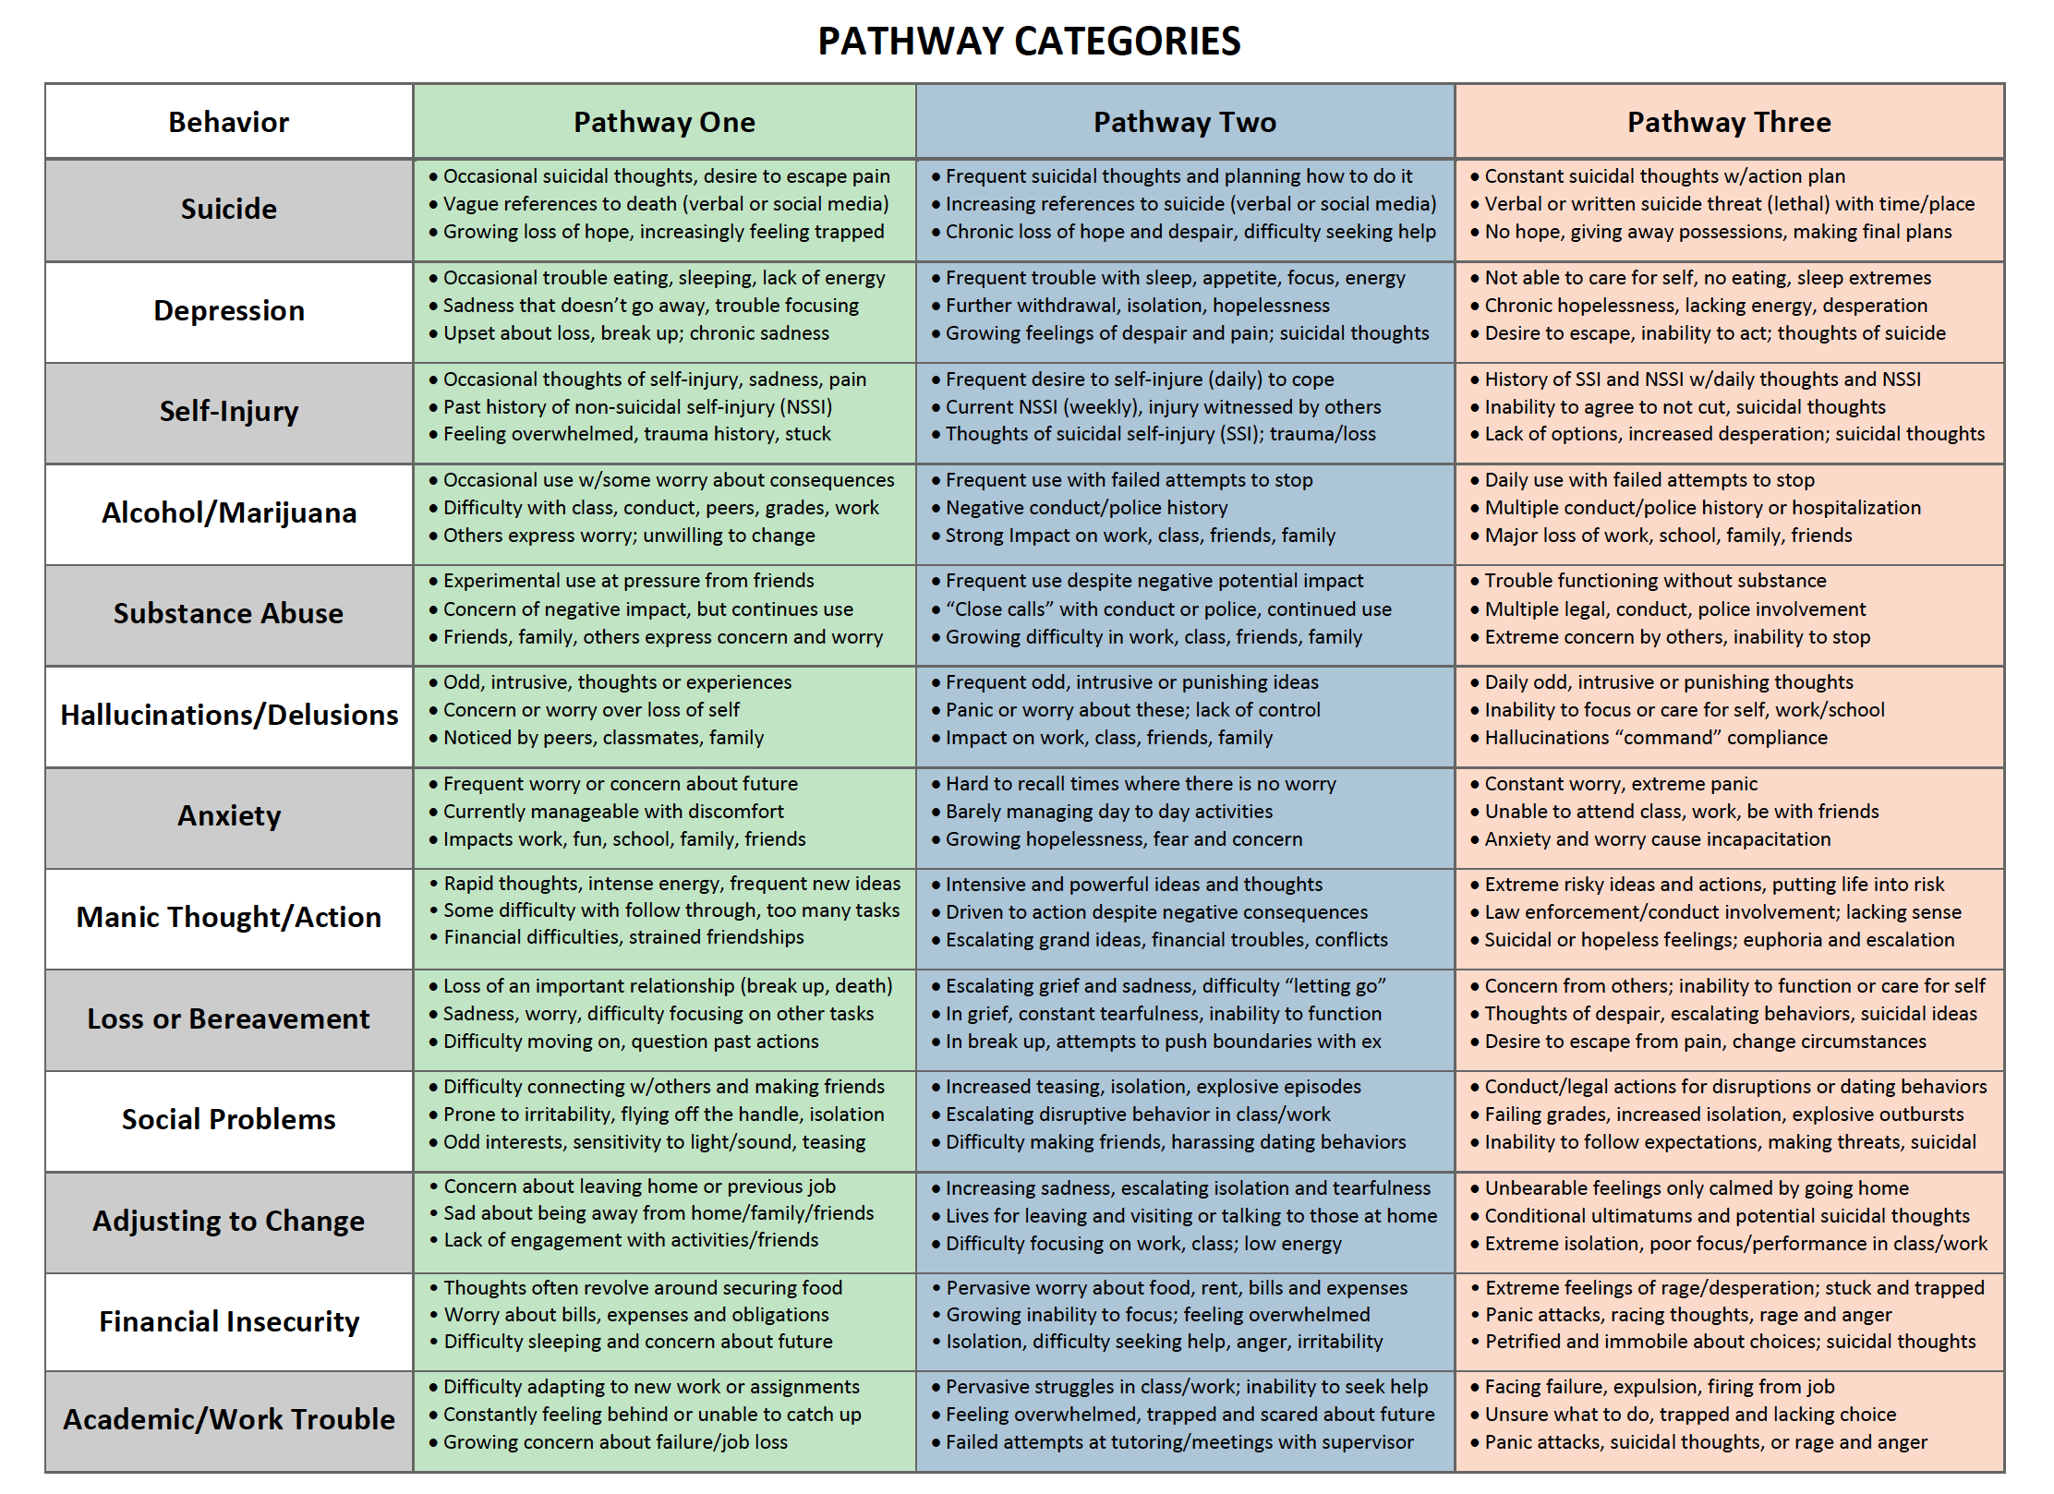
Appendix A: Pathways Tool
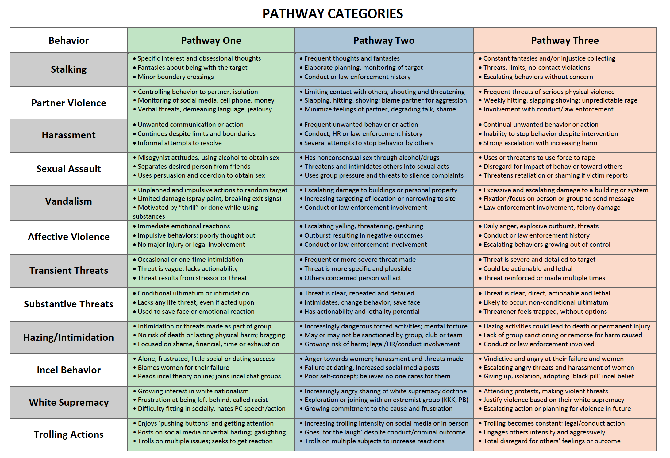

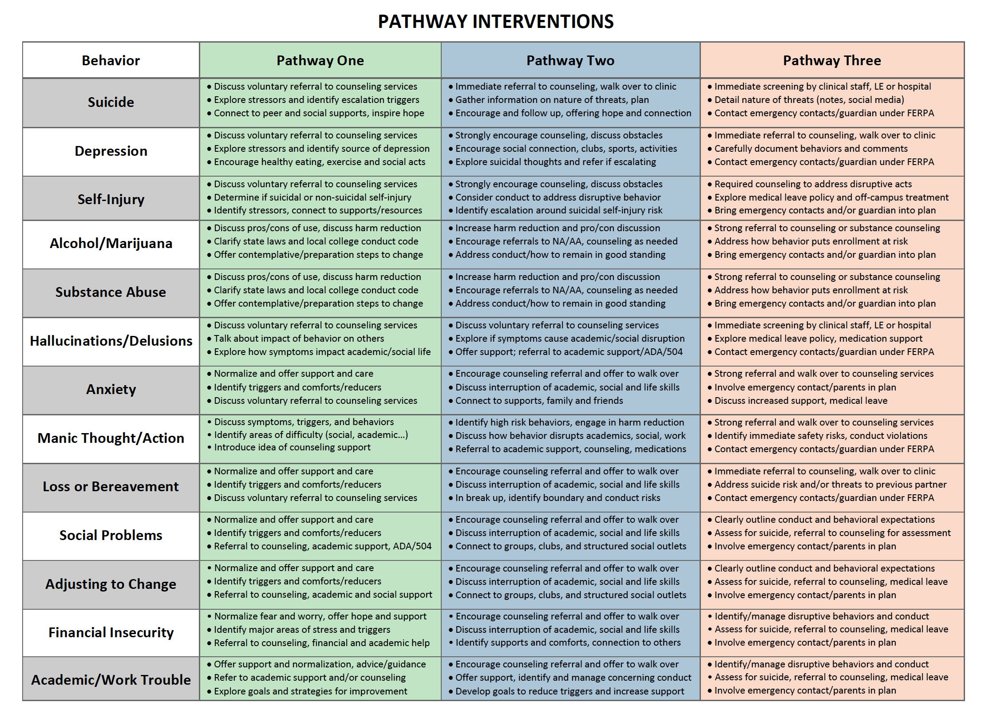
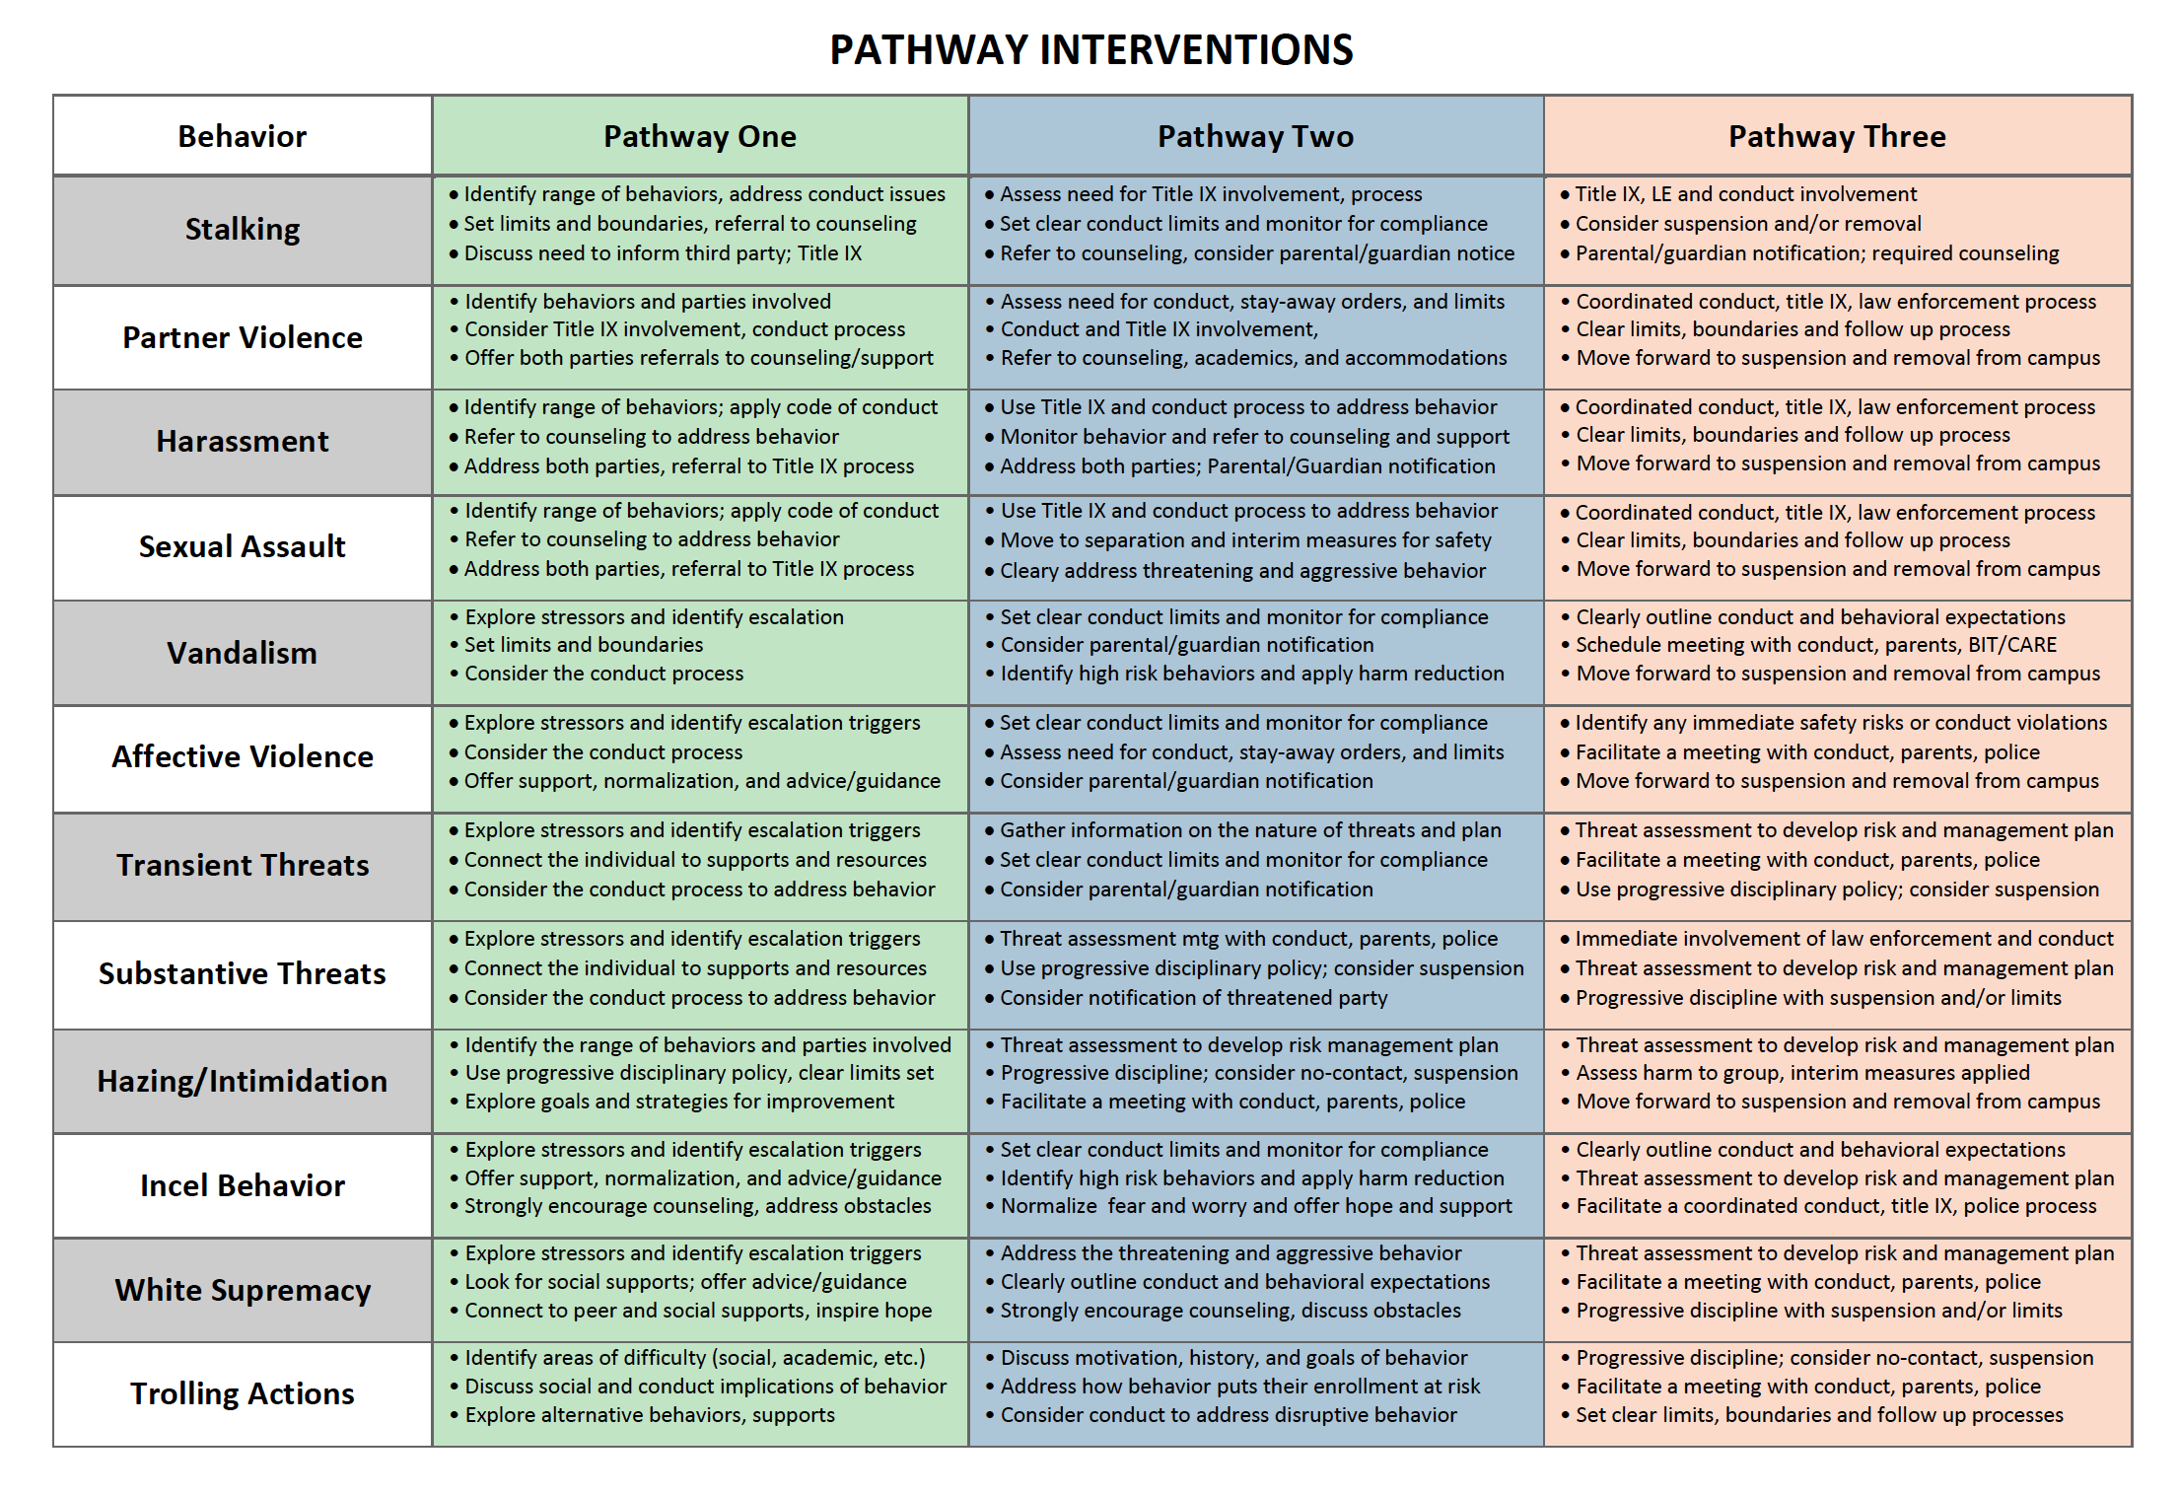

Appendix B: Reporting Form

Appendix C: Website

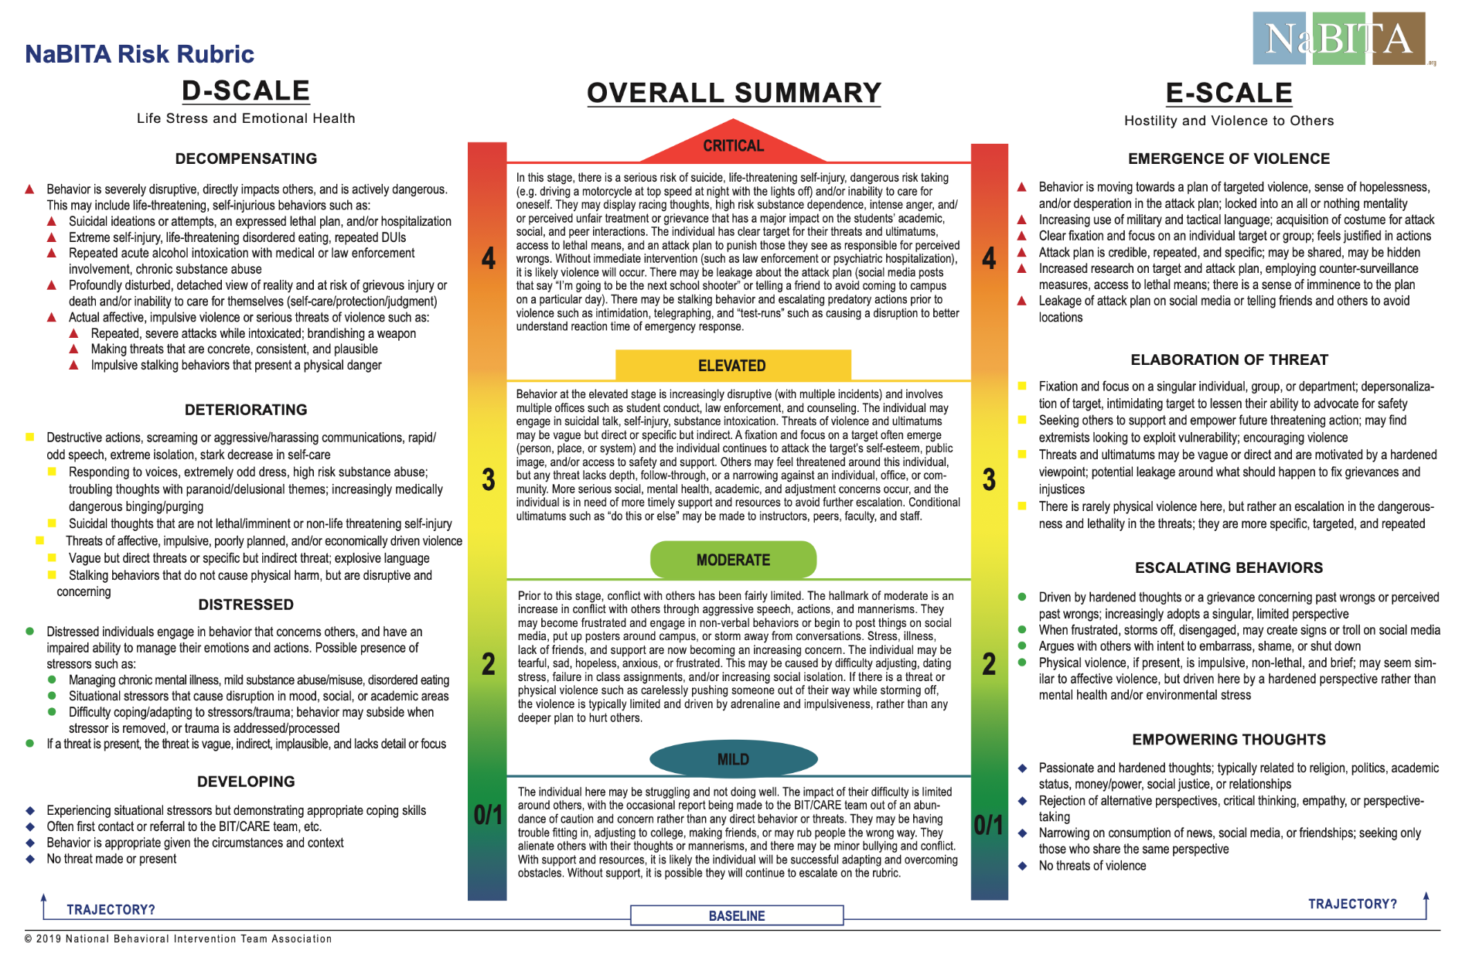
Appendix D: NABITA Risk Rubric

https://cdn.nabita.org/website-media/nabita.org/wp-content/uploads/2019/06/17205352/NaBITA-Risk-Rubric-Tri-Fold-Final.pdf
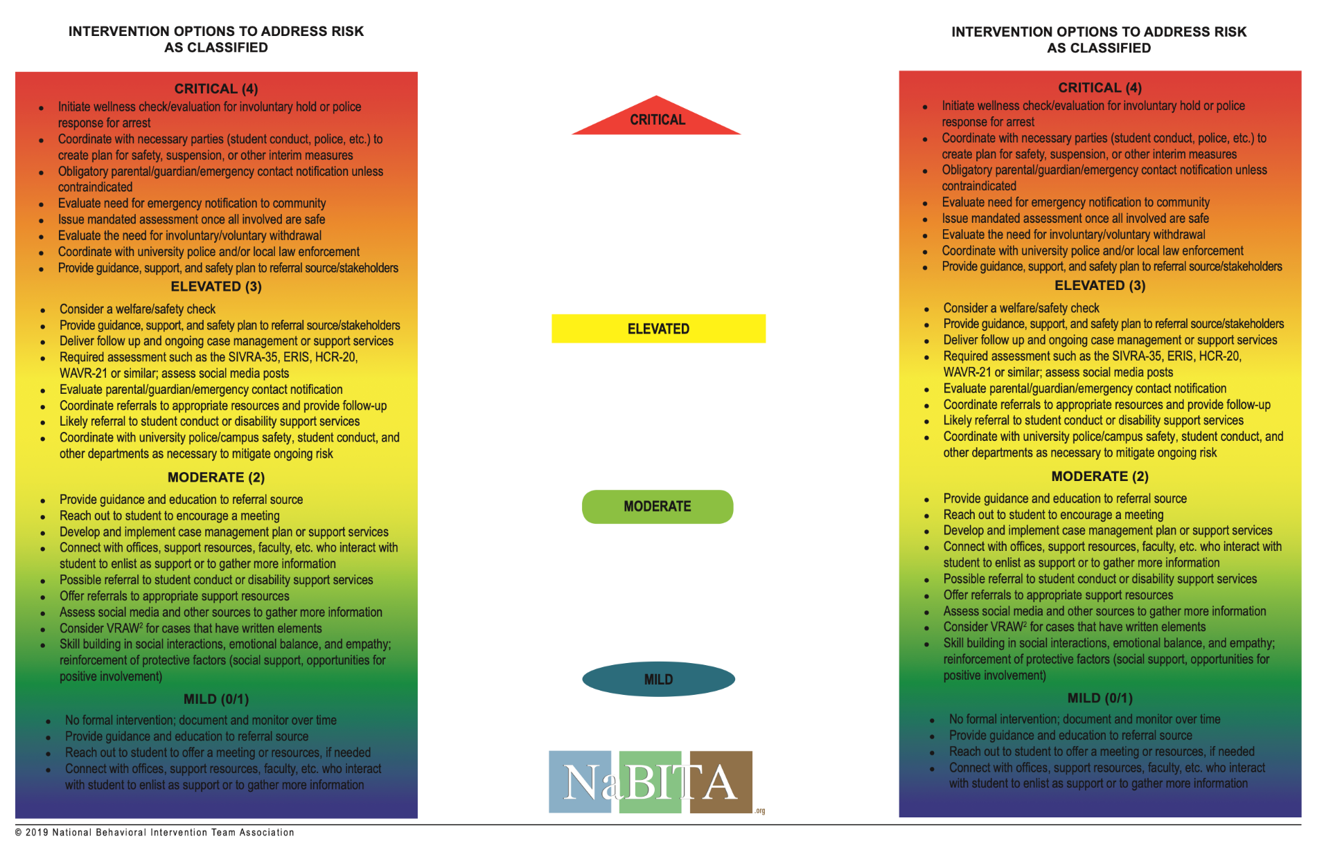

https://cdn.nabita.org/website-media/nabita.org/wp-content/uploads/2019/06/17205352/NaBITA-Risk-Rubric-Tri-Fold-Final.pdf

Appendix E: Cornell Risk Levels
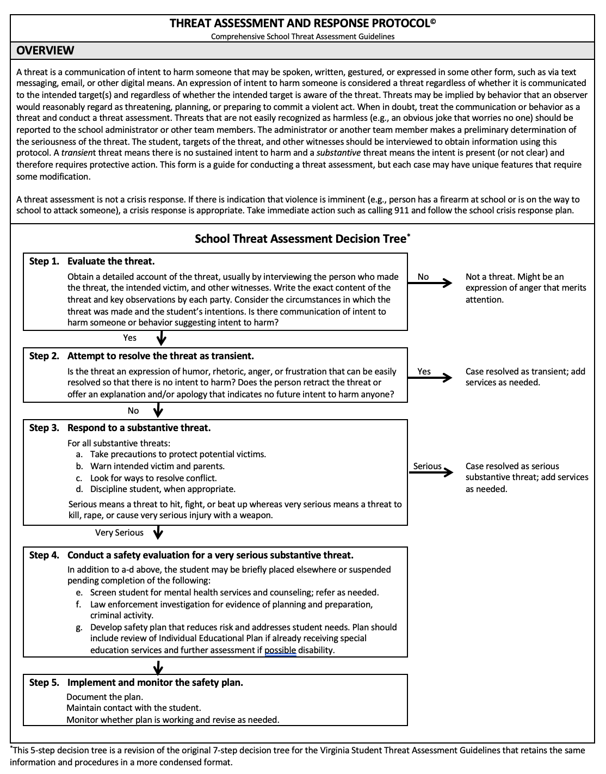
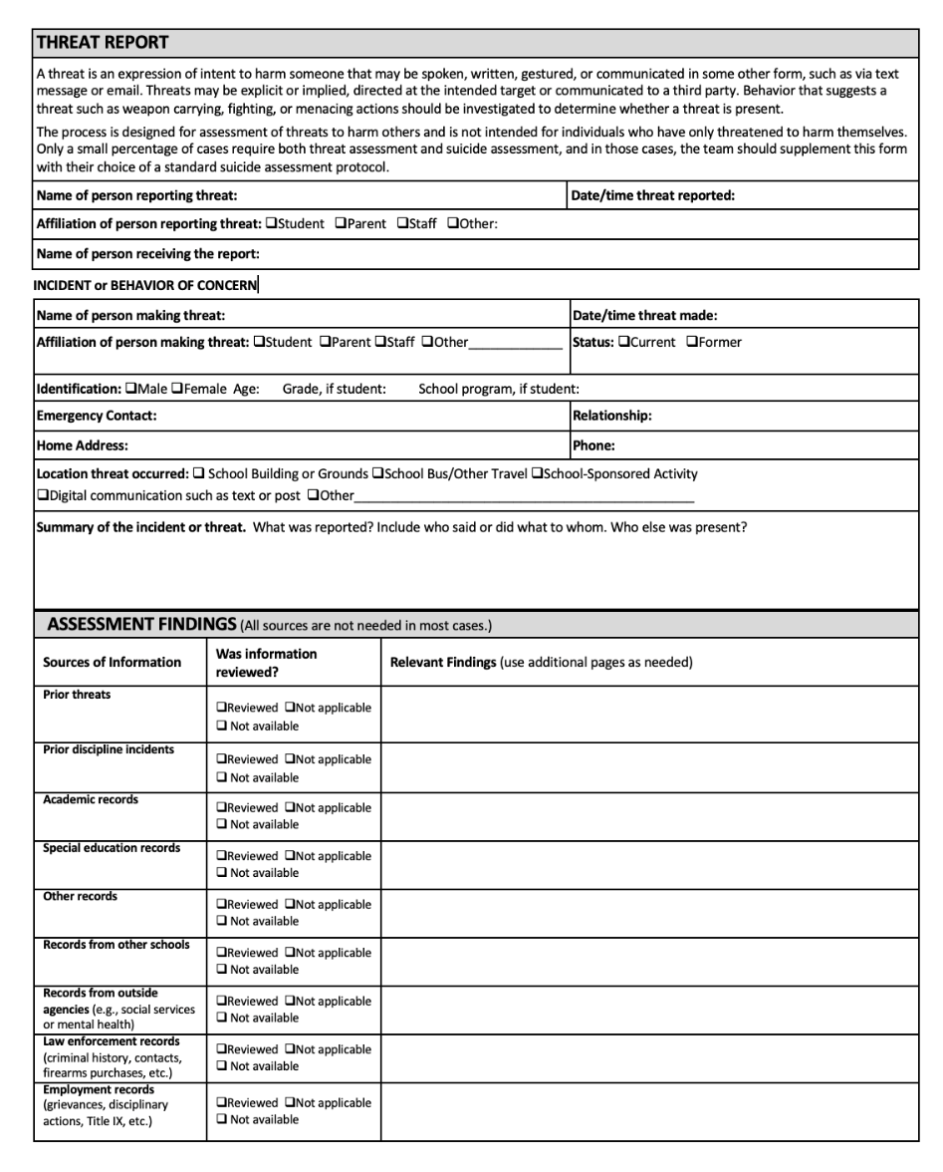

https://www.schoolta.com/manual

Appendix F: TEAM Member Agreement
I, _____________________________, understand that I am a member of [TEAM NAME], a multi-disciplinary, collaborative group who meet weekly to review concerns, determine a level of risk, and develop an intervention plan that is timely, appropriate, and commensurate with the level of risk.
The collection and analysis of data and the intervention plans are culturally competent, consider disability and difference, and are adopted in a timely manner to match the current level of risk.
As a member of the team, please initial each statement below.
___ I have read and agree to comply with the CARE Team Guide and agree to participate in meetings and training to the best of my ability.
___I understand that all information related to the CARE team, including emails, phone conversations, team discussions, online video chat and in-person conversations associated with the CARE Team are considered private and I will treat that information as such. Specifically, I will not discuss or share any case details from a CARE meeting with others not on the team without permission of the team Chair.
___ I will not transport sensitive CARE team data in an unsecured fashion. This includes unsecured emails, portable hard drives and USB/thumb drives or leave information unprotected on my university computer system or laptop.
___ I understand that none of the CARE Team records can be viewed, shared, or discussed with any non-CARE Team member due to their dynamic nature without direct permission from the chairperson of the CARE team.
___ I understand that any requests by a non-CARE Team member to view or print a CARE Team record must be made to, and approved by, the Office of the Dean of Students, as some information may need to be redacted to comply with local laws.
Signed (CARE Team Member): ____________________________ Date: ______________________
Signed (CARE Team Chair): _______________________________ Date: ______________________

Dickerson, D. (2010, February 4). Revisiting Student-At-Risk Response Teams: Threat assessment, case management, or both? Presentation at Substance Abuse and Mental Health Services Administration (SAMHSA) meeting, “Campus Suicide Prevention Grantee Technical Assistance Meeting,” Orlando, FL.
Lake, P. F., Deisinger , G. R., Eells, G. T. , Miller , L. , & Rypkema, P. (2010, February). Responding to students and employees in crisis: Emerging good practices for at-risk response teams. Pre-conference workshop presented at the Stetson University College of Law Annual National Conference for Law and Higher Education, Orlando, FL.
Dunkle, J. H., Silverstein, Z. B., and Warner, S. L. (2008). Managing Violent and Other Troubling Students: The Role of Threat Assessment Teams on Campus. Journal of College and University Law, 34, pp. 585–636.
Van Brunt, B., Reese, A. & Lewis, W. (2015). Who’s on the Team? Mission, Motivation and Membership. Berwyn, PA: National Association of Behavioral Intervention Teams (NaBITA).
Eells, G. T. and Rockland-Miller, H. S. (2011). Assessing and Responding to Disturbed and Disturbing Students: Under- standing the Role of Administrative Teams in Institutions of Higher Education. Journal of College Student Psychotherapy, 25 (1), pp. 8–23.
National Threat Assessment Center (2018). Enhancing School Safety Using a Threat Assessment Model: An Operational Guide for Preventing Targeted School Violence. U.S. Secret Service, Department of Homeland Security.
Van Brunt, B. (2012). Ending Campus Violence: New Approaches to Prevention. NY, NY: Routledge.
Van Brunt, B. (2014). The Assessment of Behavioral Intervention Teams: CORE-Q10. Berwyn, PA: National Association of Behavioral Intervention Teams (NaBITA).
Van Brunt, B. (2018). CARE Team Policies & Procedures Manual. Berwyn, PA: National Association of Behavioral Intervention Teams (NaBITA).
Sokolow, B., Lewis, S., Van Brunt, B., Schuster, S., and Swinton, D. (2014). The Book on BIT, Second Edition. Berwyn, PA: National Association of Behavioral Intervention Teams (NaBITA).
Jarvis, J. and Scherer, A. (2015) Mass Victimization: Promising Avenues for Prevention. Washington D.C: Federal Bureau of Investigation.
National Threat Assessment Center (2018). Enhancing School Safety Using a Threat Assessment Model: An Operational Guide for Preventing Targeted School Violence. U.S. Secret Service, Department of Homeland Security.
Department of Justice (DOJ)/Federal Bureau of Investigation (FBI). (2017). Making Prevention a Reality: Identifying, Assessing, and Managing the Threat of Targeted Attacks. Behavioral Analysis Unit: National Center for the Analysis of Violent Crime.
Van Brunt, B. (2018). CARE Team Policies & Procedures Manual. Berwyn, PA: National Association of Behavioral Intervention Teams (NaBITA).
The Higher Education Mental Health Alliance (HEMHA) (2013). Balancing Safety and Support on Campus: A Guide for Campus Teams. Published by the Jed Foundation.
Sokolow, B., Lewis, W., Schuster, S., Swinton, D., and Van Brunt, B. (2014). Threat Assessment in the Campus Setting: The NaBITA 2014 White paper. Berwyn, PA: National Association of Behavioral Intervention Teams (NaBITA).
National Threat Assessment Center (2018). Enhancing School Safety Using a Threat Assessment Model: An Operational Guide for Preventing Targeted School Violence. U.S. Secret Service, Department of Homeland Security.
Van Brunt, B. (2012). Case Management in Higher Education. A joint publication of the National Behavioral Intervention Team Association and the American College Counseling Association.
Vossekuil, B., Reddy, M., Fein, R., Borum, R. & Modzeleski, M. (2000). USSS Safe School Initiative: An Interim Report on the Prevention of Targeted Violence in Schools. Washington, DC: US Secret Service, National Threat Assessment Center.
Meloy , J. R. , Hoffmann , J. , Guldimann , A. & James , D. ( 2011 ). The Role of Warning Behaviors inThreat Assessment: An Exploration and Suggested Typology. Behavioral Sciences and the Law
Kanan, L. (2010). When Students Make Threats (pp. 24–9). Reston, VA: National Association of Secondary School Principals (NASSP).
www.secretservice.gov/sites/default/files/reports/2020-06/USSS_NTAC_Enhancing_School_Safety_Guide_7.11.18.pdf www.secretservice.gov/sites/default/files/2020-04/Protecting_Americas_Schools.pdf
Van Brunt & Murphy (2018). A Staff Guide to Addressing Disruptive and Dangerous Behavior on Campus. Routledge. Van Brunt & Lewis (2014). A Faculty Guide to Addressing Disruptive and Dangerous Behavior. Routledge.
Calhoun, F., & Weston, S. (2009). Threat assessment and management strategies: Identifying the howlers and hunters. Boca Raton, FL: CRC Press. Turner J. & Gelles M. (2003). Threat assessment: A risk management approach. New York: Routledge.
Weisenback Keller, E., Hughes, S. & Hertz, G. (2011). A model for assessment and mitigation of threats on college campus. Journal of Educational Administration, 49 (1): 76 – 94.
Van Brunt (2015). Harm to Others: The Assessment and Treatment of Dangerousness. American Counseling Association.
Van Brunt & Murphy (2018). A Staff Guide to Addressing Disruptive and Dangerous Behavior on Campus
Joiner, T. (2005). Why people die by suicide. Cambridge, MA: Harvard University Press.
O’Connor, R. & Portzky, G. (2018). The relationship between entrapment and suicidal behavior through the lens of integrated motivational volitional model of suicidal behavior. Current Opinions in Psychology, 22, 12–17.
Klonsky, D. & May, A. (2015). The three-step theory (3ST): A new theory of suicide rooted in the “ideation-to-action framework. International Journal of Cognitive Therapy, 8, 114–129.
Ibid.
Ibid.
Ibid.
May, A. & Klonsky, E. (2016). What distinguishes suicide attempts from suicide ideators? A meta-analysis of potential factors. Clinical Psychology: Science and Practice, 23, 5–20.
O’Connor, R. & Portzky, G. (2018). The relationship between entrapment and suicidal behavior through the lens of integrated motivational volitional model of suicidal behavior. Current Opinions in Psychology, 22, 12–17.
Barber, C. & Miller, M. (2014). Reducing a suicidal person’s access to lethal means of suicide: A research agenda. Am J Prev Med, 47(3S2): S264.
Buus Florentine J. & Crane, C. (2010). Suicide prevention by limiting access to methods: A review of theory and practice. Social Science & Medicine, 70, 1628.
McGirr, A., Renaud, J., Bureau, A., Seguin, M., Lesage, A. & Turecki, G. (2007). Impulsive-aggressive behaviors and completed suicide across the life cycle: a predisposition for younger age of suicide. doi:10.1017/
Knapp, S. (2020). Suicide prevention: An ethically and scientifically informed approach. Washington, DC. The American Psychological Association.
Suicide Prevention Resource Center & Rodgers, P. (2011). Understanding risk and protective factors for suicide: A primer for preventing suicide. Newton, MA: Education Development Center, Inc.
McLellan A. T. (2017). Substance misuse and substance use disorders: Why do they matter in healthcare? Transactions of the American Clinical and Climatological Association, 128, 112–130.
National Center for Injury Prevention and Control (2019, September). Risk and Protective Factors.
Van Brunt, B. & Murphy, A. (2018). A staff guide to addressing disruptive and dangerous behavior on campus. New York: Taylor and Francis.
Van Brunt, B. & Lewis, W. (2014). A faculty guide to disruptive and dangerous behavior in the classroom. New York: Routledge.
Whitlock, J., Minton, R., Babington, P. & Ernhout, C. (2015). The relationship between non-suicidal self-injury and suicide. The Information Brief Series, Cornell Research Program on Self-Injury and Recovery. Cornell University, Ithaca, NY.
Merrill, G. (2013). Assessing Client Dangerousness to Self and Others: Stratified Risk Management Approaches.
National Center for Injury Prevention and Control (2019, September). Risk and Protective Factors.
Davidson, Lucy E., & Gould, M.S. (1989). Contagion as a risk factor for youth suicide. In Report of the Secretary’s task force on youth suicide, risk factors for youth suicide, 2, 88-109. Washington, DC: U.S. Department of Health and Human Services, Public Health Service.
Pressman DE. (2009). Risk Assessment Decisions for Violent Political Extremism. (Her Majesty the Queen in Right of Canada, Ottawa).
Bhui KS, Silva MJ, Topciu RA, Jones E. (2016). Pathways to sympathies for violent protest and terrorism. Br J Psychiatry. 209, 483–490.
Kurzman C. (2011). The Missing Martyrs: Why There Are So Few Muslim Terrorists. (University Press, Oxford).
www.sprc.org/comprehensive-approach/effective-care
www.sprc.org/comprehensive-approach/reduce-means
Meloy, J. R., Hart, S., & Hoffmann, J. (2014). Threat assessment and management. In J. R. Meloy & J. Hoffmann (Eds.), The international handbook of threat assessment (p. 5). New York, NY: Oxford University Press.
Howard, P. (1999). The Owner’s Manual for the Brain: Everyday applications from Mind-Brain Research (2nd Ed.). Austin, TX: Bard Press.
Grossman, D. (1996). On Killing, the Psychological Cost of Learning to Kill in War and Society. New York: Back Bay Books.
Grossman, D. & Siddle, B. (2000). Psychological effects of combat, in Encyclopedia of Violence, Peace and Conflict.UK: Academic Press.
Hart, A. (1995). Adrenaline and Stress, the Exciting New Breakthrough that Helps You Overcome Stress Damage. Nashville, TN: Nelson Press.
McEllistrem, J. (2004). Affective and predatory violence: A bimodal classification systems of human aggression and violence. Journal of Aggression and Violent Behavior, 10, 1–30.
Van Brunt, B. (2012). Ending campus violence: New approaches to prevention. New York, NY: Routledge.
www.fbi.gov/file-repository/stats-services-publications-school-shooter-school-shooter/view
www.dhs.gov/sites/default/files/publications/18_0711_USSS_NTAC-Enhancing-School-Safety-Guide.pdf
www.nalc.org/workplace-issues/resources/manuals/pub108.pdf
www.nabita.org
www.atapworldwide.org
Van Brunt, B., Murphy, A. and Zedginidze, A. (2017). An Exploration of the Risk, Protective, and Mobilization Factors Related to Violent Extremism in College Populations. Journal of Violence and Gender, 4(3), p. 81-101.
FERPA — Family Educational Rights and Privacy Act. https://www2.ed.gov/policy/gen/guid/fpco/ferpa/index.html
https://cdn.nabita.org/website-media/nabita.org/wordpress/wp-content/uploads/2018/08/NaBITA-2018-Whitepaper-Final.pdf
“2014 ACA Code of Ethics” (2014). American Counseling Association. https://www.counseling.org/resources/aca-code-of-ethics.pdf.
HIPAA — Health Insurance Portability and Accountability Act. https://www.hhs.gov/hipaa/index.html
Schiemann, M., & Molnar, J. (2019). A practical guide to case management in higher education. PA, King of Prussia: The National Behavioral Intervention Team Association.
Van Brunt (2012). Ending Campus Violence. Routledge.
Pollack, W., Modzeleski, W. & Rooney, G. (2008). Prior Knowledge of Potential School-based Violence: Information students learn may prevent a targeted attack. Washington, DC: United States Secret Services, and United States Department of Education
Van Brunt, B. (2020). Journal of Campus Behavioral Intervention. (8), NABITA.
https://cdn.nabita.org/website-media/nabita.org/wp-content/uploads/2019/03/05153446/NaBITA2019statement.pdf
https://www.dprepsafety.com/audit
Sokolow, B., Lewis, S., Van Brunt, B., Schuster, S., and Swinton, D. (2014). The Book on BIT, (2nd ed.). Berwyn, PA: National Association of Behavioral Intervention Teams (NaBITA).
Van Brunt, B. (2012). Ending Campus Violence: New Approaches to Prevention. NY,NY: Routledge.
Deisinger, G., Randazzo, M., O’Neill, D., & Savage, J. (2008). The Handbook for Campus Threat Assessment and Management Teams. Stoneham, MA: Applied Risk Management.
Sokolow, B., Lewis, W., Manzon, L., Schuster, S., Byrnes, J. & Van Brunt, B. (2011). Book on BIT. www.nabita.org.
Sokolow, B., Lewis, S., Van Brunt, B., Schuster, S., and Swinton, D. (2014). The Book on BIT, (2nd ed.). Berwyn, PA: National Association of Behavioral Intervention Teams (NaBITA).
Van Brunt, B. (2012). Ending Campus Violence: New Approaches to Prevention. NY,NY: Routledge.
Nolan, J. J., Randazzo, M. R., and Deisinger, G. (2011). Campus Threat Assessment and Management Teams: What Risk Managers Need to Know Now. University Risk Management and Insurance Association (URMIA) Journal.
The Higher Education Mental Health Alliance (HEMHA) (2013). Balancing Safety and Support on Campus: A Guide for Campus Teams. Published by the Jed Foundation.
Van Brunt, B. (2012). Ending Campus Violence: New Approaches to Prevention. NY,NY: Routledge.
The Higher Education Mental Health Alliance (HEMHA) (2013). Balancing Safety and Support on Campus: A Guide for Campus Teams. Published by the Jed Foundation.
The Higher Education Mental Health Alliance (HEMHA) (2013). Balancing Safety and Support on Campus: A Guide for Campus Teams. Published by the Jed Foundation.
Van Brunt, B. (2012). Ending Campus Violence: New Approaches to Prevention. NY,NY: Routledge.
National Threat Assessment Center (2018). Enhancing School Safety Using a Threat Assessment Model: An Operational Guide for Preventing Targeted School Violence. U.S. Secret Service, Department of Homeland Security.
Van Brunt, B., Schiemann, M., Pescara-Kovach, L., Murphy, A., and Halligan-Avery, E. (2018). Standards for Behavioral Intervention Teams. Journal of Behavioral Intervention Teams, pp. 29–41).
National Threat Assessment Center (2018). Enhancing School Safety Using a Threat Assessment Model: An Operational Guide for Preventing Targeted School Violence. U.S. Secret Service, Department of Homeland Security.
Van Brunt, B. (2012). Ending Campus Violence: New Approaches to Prevention. NY, NY: Routledge.
Van Brunt, B. (2014). The Assessment of Behavioral Intervention Teams: CORE-Q10. Berwyn, PA: National Association of Behavioral Intervention Teams (NaBITA).
Van Brunt, B. (2018). CARE Team Policies & Procedures Manual. Berwyn, PA: National Association of Behavioral Intervention Teams (NaBITA).
Van Brunt, B. (2018). CARE Team Policies & Procedures Manual. Berwyn, PA: National Association of Behavioral Intervention Teams (NaBITA).
National Threat Assessment Center (2018). Enhancing School Safety Using a Threat Assessment Model: An Operational Guide for Preventing Targeted School Violence. U.S. Secret Service, Department of Homeland Security.
Gua, S. and Jamal, Z. (2007). Nurturing Cultural Diversity in Higher Education: A Critical Review of Selected Models. Canadian Journal of Higher Education, v37 n3 p27-49.
Chen, A. (2017). Addressing diversity on college campuses: Changing expectations and practices in instructional leadership. Higher Education Studies, 7(2).
Jaschik, S. (9/18/2018b). Walking on campus…while black. Inside higher ed. Retrieved from https://www.insidehighered.com/news/2018/09/18/incident-umass-latest-which-calls-campus-police-suggest-racial-profiling
Crenshaw, K., Gotanda, N, Peller, G & Thomas, K (Eds) (1995). Critical Race Theory: The Key Writings that Formed the Movement. The New Press.
DiAngelo, R. (2018). White fragility: Why it’s so hard for white people to talk about racism. Beacon Press
Van Brunt, B., Woodley, E., Gunn, J., Raleigh, MJ, Reinach Wolf, C. & Sokolow, B. (2012). Case Management in Higher Education. Publication of the National Behavioral Intervention Team Association (NaBITA) and the American College Counseling Association (ACCA).
Pena, E. & Kocur, J. (2013). Parents' Experiences in the Transition of Students with Autism Spectrum Disorders to Community College. Journal of Applied Research in the Community College, Volume 20, Number 2, Spring 2013, pp. 25-32(8)
Patrick Flink (2021) Person-First & Identity-First Language: Supporting Students with Disabilities on Campus, Community College Journal of Research and Practice, 45:2, 79-85, DOI: 10.1080/10668926.2019.1640147
Timmerman, L. C., & Mulvihill, T. M. (2015). Accommodations in the College Setting: The Perspectives of Students Living with Disabilities. The Qualitative Report, 20(10), 1609-1625. Retrieved from http://nsuworks.nova.edu/tqr/vol20/iss10/5
Greenstein, K. and Calhoun, D. W. (2017). Reporting Behaviors of Faculty and Staff to a Campus Behavior Assessment Team. College Student Affairs Journal, 35 (2), pp. 44–56.
Sokolow, B., Lewis, S., Van Brunt, B., Schuster, S., and Swinton, D. (2014). The Book on BIT, (2nd ed.). Berwyn, PA: National Association of Behavioral Intervention Teams (NaBITA).
Jarvis, J. and Scherer, A. (2015) Mass Victimization: Promising Avenues for Prevention. Washington D.C: Federal Bureau of Investigation.
Greenstein, K. and Calhoun, D. W. (2017). Reporting Behaviors of Faculty and Staff to a Campus Behavior Assessment Team. College Student Affairs Journal, 35 (2), pp. 44–56.
FERPA — Family Educational Rights and Privacy Act. Retrieved from www2.ed.gov/policy/gen/guid/fpco/ferpa/index.html.
HIPAA — Health Insurance Portability and Accountability Act. Retrieved from www.hhs.gov/hipaa/index.html.
Family Educational Rights and Privacy Act (FERPA). 20 U.S.C. § 1232g; 34 CFR Part 99. https://www2.ed.gov/policy/gen/guid/fpco/ferpa/index.html
Van Brunt, B. (2012). Ending Campus Violence: New Approaches to Prevention. NY, NY: Routledge.
Van Brunt, B. (2014). The Assessment of Behavioral Intervention Teams: CORE-Q10. Berwyn, PA: National Association of Behavioral Intervention Teams (NaBITA).
Van Brunt, B. (2014). Lessons from Four Schools: Beta Testing the Core Q10. Journal of Campus Behavioral Intervention (JBIT), 2, pp. 125–132
Van Brunt, B., Murphy, A. and Zedginidze, A. (2017). An Exploration of the Risk, Protective and Mobilization Factors Related to Violent Extremism in College Populations. Journal of Gender and Violence, 4(3), pp. 81–101.
Sokolow, B., Van Brunt, B., Lewis, W., Schiemann, M., Murphy, A., Molnar, J. (2019). The NaBITA Risk Rubric College and University Edition. Berwyn, PA.
Van Brunt, B. (2016). Assessing Threat in Written Communications, Social Media, and Creative Writing. Journal of Violence and Gender, 3(2), pp. 78–88.
National Threat Assessment Center (2018). Enhancing School Safety Using a Threat Assessment Model: An Operational Guide for Preventing Targeted School Violence. U.S. Secret Service, Department of Homeland Security.
Van Brunt, B. (2015). Harm to Others: The Assessment and Treatment of Dangerousness. Alexandria, VA: American Counseling Association.
Sokolow, B., Lewis, W., Schuster, S., Swinton, D., and Van Brunt, B. (2014). Threat Assessment in the Campus Setting: The NaBITA 2014 White paper. Berwyn, PA: National Association of Behavioral Intervention Teams (NaBITA).
Department of Justice (DOJ)/Federal Bureau of Investigation (FBI). (2017). Making Prevention a Reality: Identifying, Assessing, and Managing the Threat of Targeted Attacks. Behavioral Analysis Unit: National Center for the Analysis of Violent Crime.
Most lawsuits related to BIT/CARE and threat assessment work are based on inconsistencies between the assessment of risk and the assignment of interventions. A secondary source of lawsuits is based on unmitigated bias related to contextual information gathering, subjective decision-making and misses related to past case data.
Calhoun, F., & Weston, S. (2009). Threat assessment and management strategies: Identifying the howlers and hunters. Boca Raton, FL: CRC Press. Turner J. & Gelles M. (2003). Threat assessment: A risk management approach. New York: Routledge.
Shaw, J. D. and Westfall, S. B. (2015). Behavior Intervention and Case Management. In B. H. LaBanc and B. O. Hemphill (Eds.), College in the Crosshairs: An Administrative Perspective on Prevention of Gun Violence, pp. 144–164).
Van Brunt, B. (2012). Case Management in Higher Education. A joint publication of the National Behavioral Intervention Team Association and the American College Counseling Association.
Nolan, J. J., Randazzo, M. R., and Deisinger, G. (2011). Campus Threat Assessment and Management Teams: What Risk Managers Need to Know Now. University Risk Management and Insurance Association (URMIA) Journal.
The Higher Education Mental Health Alliance (HEMHA) (2013). Balancing Safety and Support on Campus: A Guide for Campus Teams. Published by the Jed Foundation.
Van Brunt, B. (2012). Ending Campus Violence: New Approaches to Prevention. NY, NY: Routledge.
The Higher Education Mental Health Alliance (HEMHA) (2013). Balancing Safety and Support on Campus: A Guide for Campus Teams. Published by the Jed Foundation.
Van Brunt, B. (2018). CARE Team Policies & Procedures Manual. Berwyn, PA: National Association of Behavioral Intervention Teams (NaBITA).
Van Brunt, B. (2014). The Assessment of Behavioral Intervention Teams: CORE-Q10. Berwyn, PA: National Association of Behavioral Intervention Teams (NaBITA).
Fitch, P. and Van Brunt, B. (2016). A Guide to Leadership and Management in Higher Education: Managing Across Generations. NY: NY, Taylor and Francis.
Hoban, J. (2014). Who’s Minding the Shop? Attending to the Well Being of the Team by Jeannie Hoban. JBIT pp. 88–98.
Klein, LB (2016). Fostering Compassion Satisfaction Among College & University Title IX Administrators. Journal of Campus IX, pp. 58–75)
Van Brunt, B. (2017). Brief BITS: Tabletop Trainings for the Behavioral Intervention Team (BIT). CG Communication & Design. Valrico, FL.
National Threat Assessment Center (2018). Enhancing School Safety Using a Threat Assessment Model: An Operational Guide for Preventing Targeted School Violence. U.S. Secret Service, Department of Homeland Security.
Department of Justice (DOJ)/Federal Bureau of Investigation (FBI). (2017). Making Prevention a Reality: Identifying, Assessing, and Managing the Threat of Targeted Attacks. Behavioral Analysis Unit: National Center for the Analysis of Violent Crime.
Jarvis, J. and Scherer, A. (2015) Mass Victimization: Promising Avenues for Prevention. Washington D.C: Federal Bureau of Investigation.
Fitzpatrick, J., Sanders, J., and Worthen, B. (2010). Program Evaluation: Alternative Approaches and Practical Guidelines (4th Edition). New York, NY: Pearson Publications.
Elliot, G. and Reese, C. (2014). Behavioral Intervention Teams and End-of-Semester Reporting. Journal of Campus Behavioral Intervention (JBIT), 2, pp. 19–35.
Stufflebeam, D. and Shinkfield, A. (1985). Systematic Evaluation. Norwell, MA: Kluwer-Nijhoff.
Stufflebeam, D. (2000). The CIPP Model Evaluation. In D. L. Shufflebeam, D. L., Madaus, G. F., and Kelleghan, T. (2000). Evaluation Models: Viewpoints on Educational and Human Services Evaluations (2nd Ed.), pp. 274–317.
Fitzpatrick, J., Sanders, J., and Worthen, B. (2010). Program Evaluation: Alternative Approaches and Practical Guidelines (4th Ed.). New York, NY: Pearson Publications.
Shaw, J. D. and Westfall, S. B. (2015). Behavior Intervention and Case Management. In B. H. LaBanc and B. O. Hemphill (Eds.), College in the Crosshairs: An Administrative Perspective on Prevention of Gun Violence, pp. 144–164.
Reese, C. and Drew, R. (2015). A BIT Response to a Non-Community Member Threat: A Tabletop Exercise of the Charleston, SC Shooting JBIT 2015, pp. 53–64.
Training Circular 25-20, A Leader’s Guide to After-Action Review, Headquarters, Department of the Army, Washington DC, 30 September 1993. http://www.au.af.mil/au/awc/awcgate/army/tc_25-20/table.htm
Morrison John E and Larry L Meliza. “Foundations of the After Action Review Process” U.S. Army Research Institute for the Behavioral and Social Sciences. Special Report 42, July 1999.
Keiser NL, Arthur W. A meta-analysis of the effectiveness of the after-action review (or debrief) and factors that influence its effectiveness. J Appl Psychol. 2021 Jul;106(7):1007-1032. doi: 10.1037/apl0000821. Epub 2020 Aug 27. PMID: 32852990.
Morrison, J. and Meliza, L. (1999). Foundations of the After-Action Review Process. Alexandria, VA. Institute for Defense Analysis.
The Higher Education Mental Health Alliance (HEMHA) (2013). Balancing Safety and Support on Campus: A Guide for Campus Teams. Published by the Jed Foundation.
Van Brunt, B. (2014a). The Assessment of Behavioral Intervention Teams: CORE-Q10. Berwyn, PA: National Association of Behavioral Intervention Teams (NaBITA).
Pearlman, L A. & Saakvitne, K. W. (1995). Treating therapists with vicarious traumatization and secondary traumatic stress disorders. In C. R. Figley (Ed.), Compassion fatigue: Coping with secondary traumatic stress disorders in those who treat the traumatized, 150-177. NY: Brunner/Mazel.
Stamm, B.H. (1997). Work-related Secondary Traumatic Stress. PTSD Research Quarterly, (8) 2, Spring.
McCann, I. L. and Pearlman, L. A. (1990). Vicarious traumatization: A framework for understanding the psychological effects of working with victims. Journal of Traumatic Stress, 3:2, 131-149.
Maslach, C. and Jackson, S. E. (1981). The measurement of burnout. Journal of Occupational Behavior, 2, 99-113.
Figley, C. R. (Ed.) (2003). Treating Compassion Fatigue. New York: Brunner-Routledge.
Hoban, J. (2014). Who’s Minding the Shop? Attending to the Well Being of the Team by Jeannie Hoban. JBIT pp. 88–98.
Klein, LB (2016). Fostering Compassion Satisfaction Among College & University Title IX Administrators. Journal of Campus IX, pp. 58–75)

